Stanford Stratified Structure Solver Simulation tool
Chang Liu, Xufeng Wang, Ogaga Odele, and Peter Bermel
Abstract
The Stanford Stratified Structure Solver (S4) developed in 2012 allows for fast and accurate prediction of optical propagation through complex 3D structures. However, there have been two key challenges preventing wider use to date: (i) the use of a specialized control language and (ii) the difficulty of incorporating realistic materials parameters. In this project, both concerns are addressed. We have constructed a graphical user interface as an alternative, using the open-source Rappture platform on nanoHUB. This has been combined with a comprehensive materials database known as PhotonicsDB, which incorporates materials optical data drawn from carefully vetted sources. An Octave script file was written to accept the user inputs and then generate and run an S4 control file. The results are then interpreted and displayed on the interface by the xml file. This new S4 GUI can be used to investigate and optimize multilayer antireflective coatings for solar cells. Preliminary results are also presented. In future work, it could also be applied to selective solar thermal absorber designs, which can convert sunlight into heat for direct use in hot water, or for powering mechanical engines.

Introduction
Many optical components in our daily life involve thin-film structures. These include but are not limited to the following: antireflective coatings on eyeglasses, dielectric mirrors inside a camera, and cadmium telluride solar cells. The design and optimization of these components rely on well-established numerical models and simulation tools. The Stanford Stratified Structure Solver (S4) solves the Maxwell’s Equations in frequency domain based on the S-matrix method. It is useful for analyzing optical propagation in layered periodic structures, as illustrated in Figure 1 [1]. Its programming interface allows users to call multiple specific S4 functions, through scripts written in Lua.
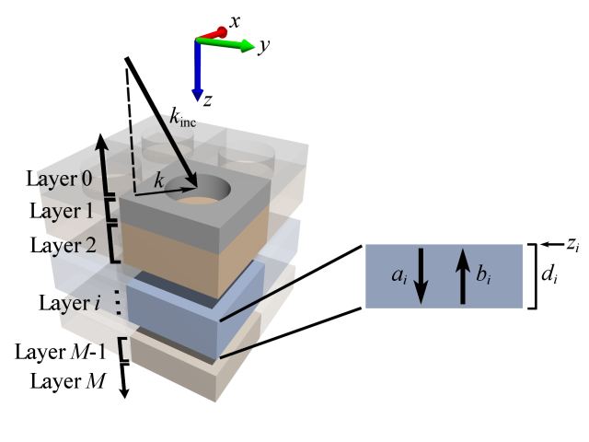
Figure 1. Example structure used for calculating the reflection and transmission of a stack of dielectric media using the S-matrix method (adapted from Ref. 1).

In early 2013, a first-generation S4 simulation tool was deployed on nanoHUB.org, which allows users to load, edit or write an input deck exclusively in the Lua scripting language. The user then runs the input deck, also known as the “control file”, to generate two types of results: raw numerical data and interactive spectral plots for the variables previously specified by the input deck. This simulation tool was more convenient than the original S4 code, since the user did not need to install the source code or run the simulation in a Lua environment, but from any web browser with Java .

However, this S4 simulation tool has two key challenges preventing wider use to date: the use of the specialized Lua scripting language inside the input deck, and the difficulty of incorporating realistic materials parameters. To mend these two flaws, a new graphical user interface (GUI) is developed in the summer of 2013. The new tool provides parameters-input interface as an additional option that generates the control file behind the scene automatically. It also connects its database to PhotonicsDB, which provides experimentally obtained dielectric constants for many materials [2].

Next, I will explain the physical and mathematical background of S4, describe the new interface, and discuss a case study using S4.

The S-Matrix Method
As mentioned in the introduction section, the S-matrix method is the core of the internal algorithm of S4. Basically, the S-matrix method is used to solve transfer matrix problems for all grating models with upward- or downward-propagating and decaying waves as shown in Figure [3]. Compared to the T-matrix method, this method is much more numerically stable for absorptive media.

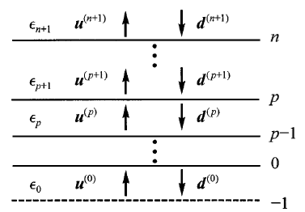
Figure 2. Abstract layered grating structure (adapted from Ref. 3).

The horizontal lines in Figure 2 represent real or numerical material interfaces. The letters u and d represent a set of wave amplitudes as column vectors for upward- and downward-propagation waves in each layer, respectively.

For an arbitrary layer p, where $0≤p≤n$, there is a stack S matrix $S^{(p)}$ satisfying the equation:
$\left[\begin{matrix}u^{(p+1)} \\ d^{(0)}\end{matrix}\right]$ = $S^{(P)}\left[\begin{matrix}u^{(0)} \\ d^{(P+1)}\end{matrix}\right]$, (1)
so that the waves in layer p+1 can be linked with medium 0. This equation can also be written in a two-by-two sub-matrix form:
$\left[\begin{matrix}u^{(p+1)} \\ d^{(0)}\end{matrix}\right]$ = $\left[\begin{matrix}T_{uu}^{(p)} & R_{ud}^{(p)} \\ R_{du}^{(p)} & T_{dd}^{(p)}\end{matrix}\right]\left[\begin{matrix}u^{(0)} \\ d^{(P+1)}\end{matrix}\right]$, (2)
where T and R are the transmission and reflection matrices, respectively. Therefore, given the transmission of the upward incident wave amplitudes in medium 0 and the reflection of the downward incident wave amplitudes in layer p+1, the upward wave amplitudes in layer p+1 and the downward wave amplitudes in medium 0 can be calculated [3]. Since the T and R values are constrained by energy conservation to be no greater than 1, the S-matrix approach is unlikely to encounter numerical instabilities such as poor condition numbers.

Specifically for the structure solved by S4, $u^{(0)}=0$, and $d^{(n)}$, which is the incident planewave, is given. So $u^{(n)}$, which is the total reflection, and $d^{(0)}$, which is the total transmission, can be easily computed as:
$u^{(n)}=R_{ud}^{(n-1)}d^{(n)}$, (3a)
and
$d^{(0)}=T_{dd}^{(n-1)}d^{(n)}$. (3b)
Then, the total absorption can be gotten by subtracting reflection and transmission from the total incident wave amplitude.

The S4 Simulation tool on nanoHUB
The S4 simulation tool is developed using the Rappture (Rapid application infrastructure) toolkit [4]. The underlying simulator supported by Rappture can be written in different programming language. We use the free and open-source Octave in this project. The application can be published on nanoHUB.org, so that users from all around the world can access the tool simply through a web browser with Java.

S4 simulation tool consists two types of input: “graphical interface” for starting users and “input deck” for advanced users.
- Graphical interface [5]
At the top, a loader provides several examples for users to simulate some common or important structures.
  - Materials selection (Figure 3)
The Number of Materials is the total number of materials that can be used in the structure. Category and specific materials can be selected from PhotonicsDB, and the descriptions of each material are also shown. Users can also opt to manually define the relative permittivity of the materials.
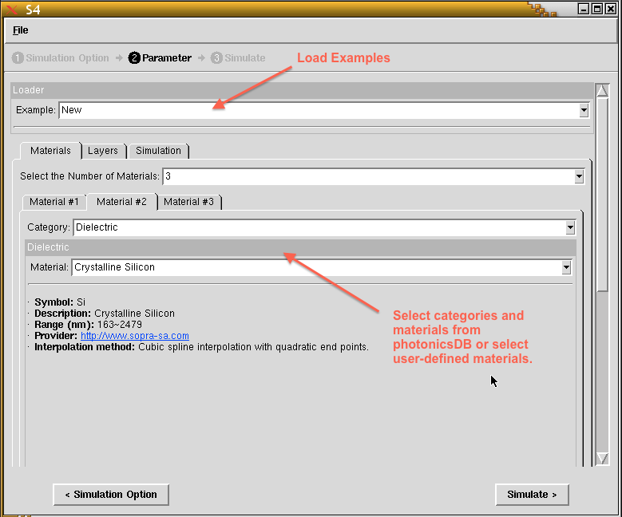
Figure 3. Materials selection interface

  - Layer configurations (Figure 4)
The lattice base vector sets the real size and place of a lattice. The S4 graphical interface supports a maximum of 10 unique layers. The user can also repeat a range of layers with a maximum of 10 periods. All the layers can be disabled or enabled for quick modification of the design. In each layer, a maximum of 2 patterns can be set.
The Poynting flux gives an output of the integral of the Poynting flux over a unit cell surface normal to the z-direction within this layer with respect to a user-defined offset. The Electromagnetic energy gives an output of a volume integral of the electromagnetic energy density over a unit cell throughout the entire thickness of the layer [1].
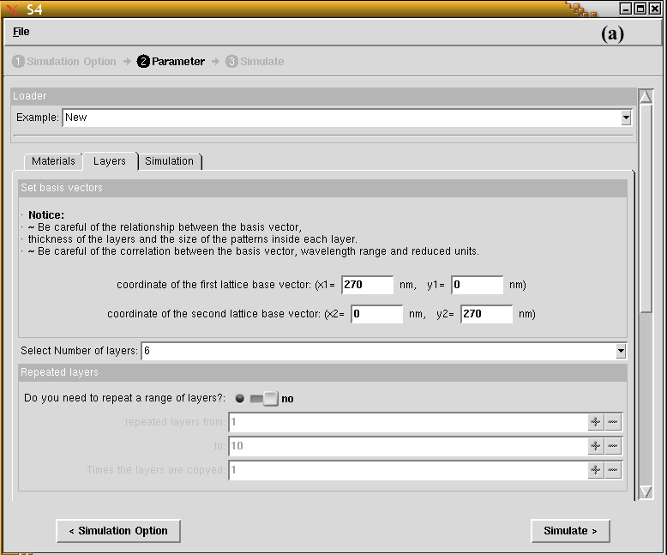

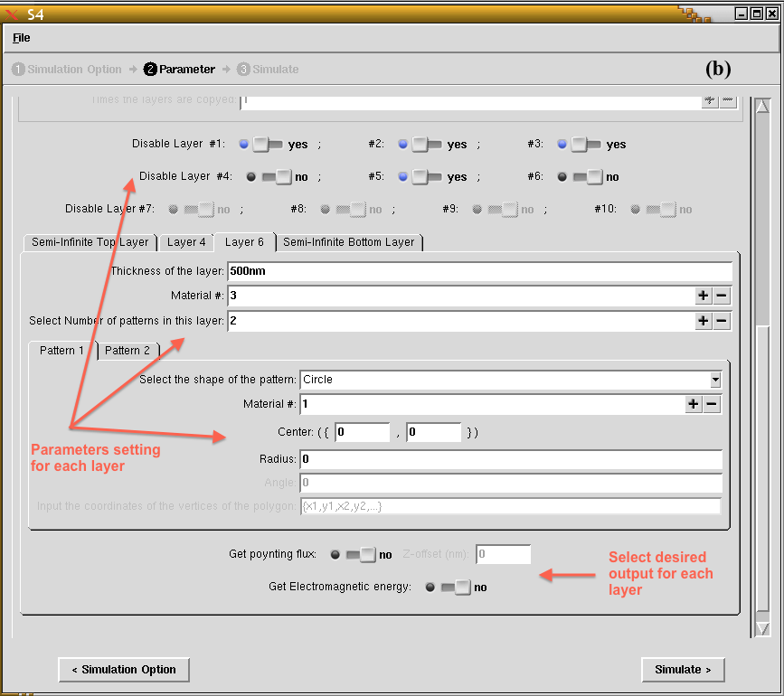
Figure 4. Layer configuration interface

  - General simulation setting (Figure 5)
The Max Fourier expansion orders set the maximum number of Fourier components to use. The Excitation planewave defines the incident planewave with the spherical coordinate angles φ and θ of the k-vector, the electric field amplitudes and phase of the s- and p-polarization of the planewave.
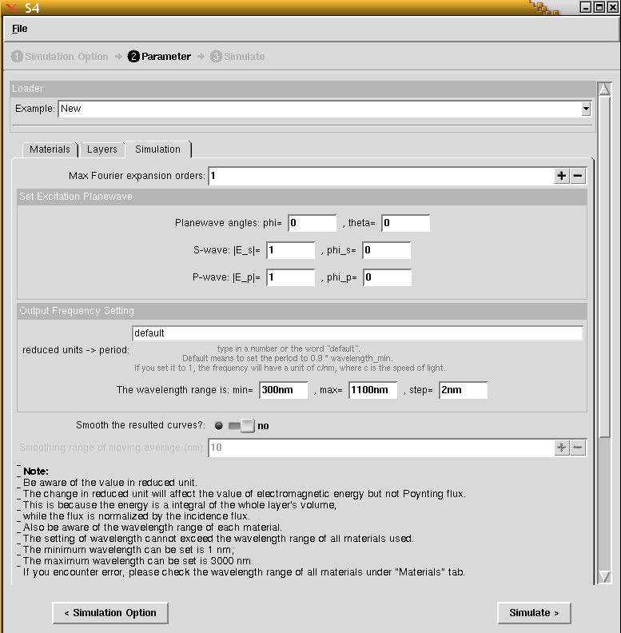
Figure 5. General simulation setting interface

- Input deck （Figure 6）
The control file needs to be written in the Lua scripting language. More complex structures and procedures can be defined without limit; advanced settings and results can also be included and generated by the control file.
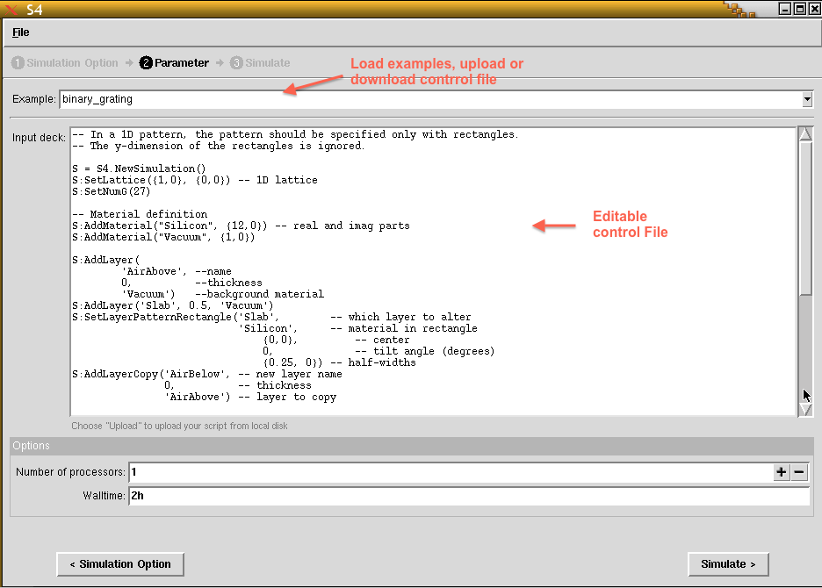
Figure 6. Input deck interface

- Outputs (Figure 7)
Three types of results will be displayed after simulating the structure: the control file (input or generated by S4sim), the output log from S4, and the spectral curves. Spectra for reflection, transmission, and integrated layer electromagnetic energy can be generated, and the raw data or resulting plots can be downloaded here.
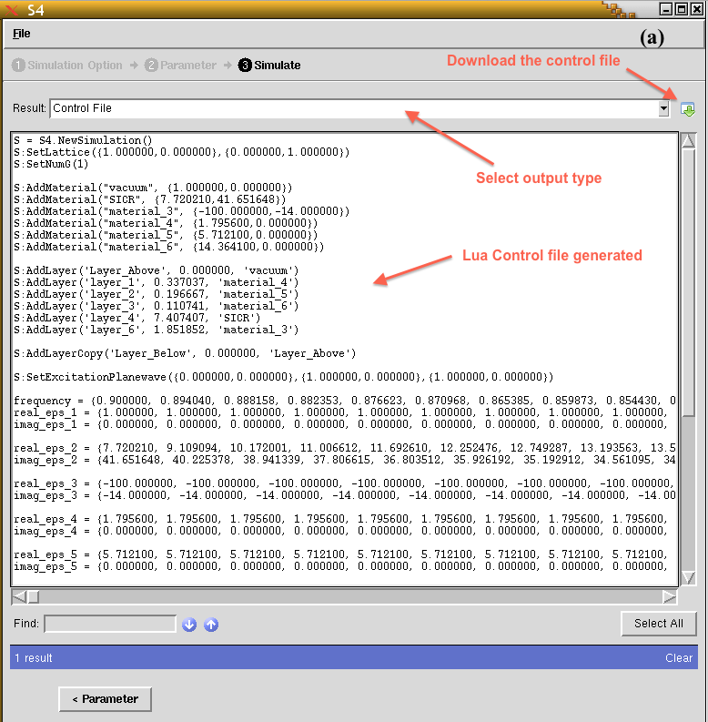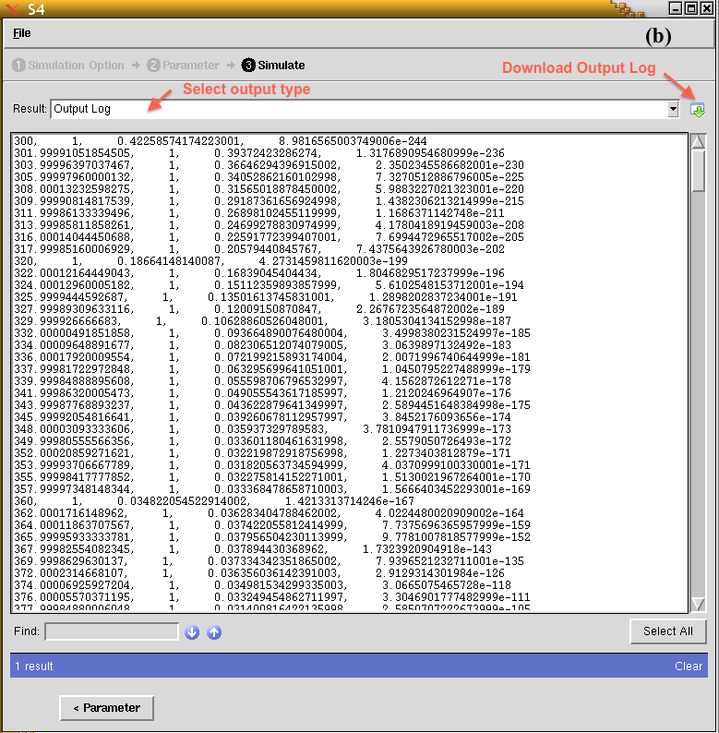
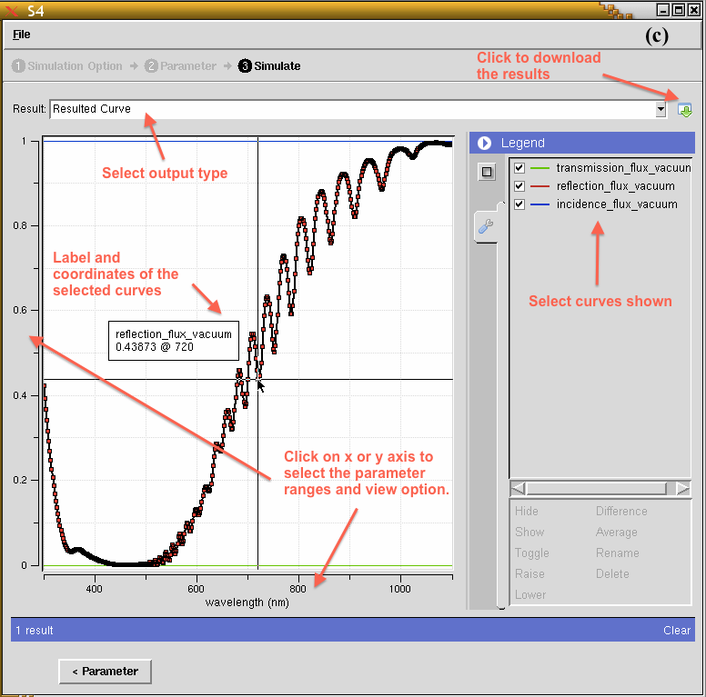
Figure 7. Outputs of (a) control file, (b) output log, and (c) spectra curves

Results and Discussion
To demonstrate the functionality of S4 simulation tool, the structures from a published research paper are simulated. The research was conducted to improve the overall efficiency of silicon photovoltaic cell by optimizing the front coatings of the cell using the S-matrix method. The structure diagrams are shown in Figure 8 [6].

Figure 8. (a) Basic structure of silicon photovoltaic cell, and (b) optimizing 1to 3 front coatings (adapted from Ref. 6).

To simulate this structure in S4 simulation tool, following parameters should be set:
- Materials:
  - Basic materials for all structure:
    - Category: Vacuum
    - Category: Dielectric; Material: Crystalline Silicon
    - Category: Set the material manually; Relative permittivity: real = -100, imaginary = -14. (This is the backside perfect metal.)
  - Front coating materials:
Number of front coating layers | 1 |  | 2 |  | 3
Relative permittivity | Real | Imag | Real | Imag | Real | Imag
Layer 1  Layer 2  Layer 3 | 4.32 | 0 | 2.37  9.12 | 0  0 | 1.80  5.71  14.36 | 0  0  0
Table 1. Relative permittivity of Front coating materials [6]

- Layers:
5 layers are set to simulate the structures. The semi-infinite top and bottom layers are set to vacuum, and the “Get Poynting flux” option should be “yes” for these two layers, with a Z-offset of 0. Layer 1, 2 and 3 are three front coating layers that can be enabled or disabled for quick structural modification by the user. Their thicknesses are shown in Table 2. Layer 4 is silicon and layer 5 is the perfect reflecting metal with thickness of 2000 nm and 500 nm respectively.

Number of front coating layers | 1 | 2 | 3
Thickness (nm)  Layer 1  Layer 2  Layer 3 | 60 | 82.3  38.9 | 91.0  53.1  29.9
Table 2. Front coatings thicknesses [6]

- Simulation:
Set the wavelength range from 300 nm to 1100 nm.
All other parameters can be left at their default values.
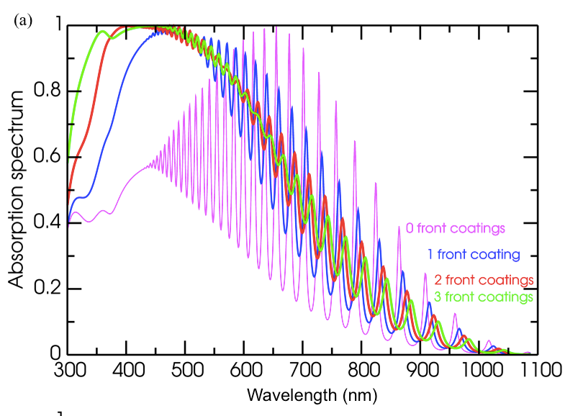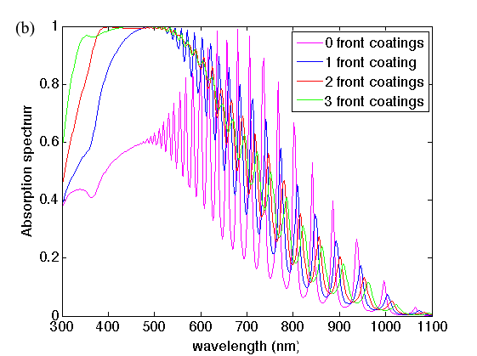
Figure 9. (a) Published results (from Ref. 6), and (b) generated results from S4

The simulation results of the structures can be downloaded, and the absorption spectra can be computed by subtracting the reflection and transmission spectra from the incident spectra. The published results and the results simulated by S4 are shown in Figure 9 for comparison. It can be seen that the fluctuation of the absorption spectra decreases evidently, and the peak absorption increases dramatically around 450 nm in wavelength as the number of front coatings increases. It is clear that the absorption spectra are very similar in both situations.

Conclusion
The new GUI on nanoHUB connects to S4 optical simulation code and the material database, PhotonicsDB. It has been demonstrated to be capable of reproducing published research results, as shown in the Results and Discussion section. The user interface is extremely flexible and allows for a wide range of optical structures in 1D, 2D and 3D.
S4 is a powerful optical simulator solving the Maxwell’s equations in the frequency domain. In this work, the usefulness of S4 is extended with the addition of a graphical user interface and connection with a material database. The GUI avoids the use of the specialized Lua scripting language required for building an S4 input deck; thus, the user can now interact with the GUI to enter input parameters in an intuitive manner, using experimentally relevant units. The connection with the material database called PhotonicsDB opens up a wealth of materials to choose from. This work has led to a web-enabled, freely available optical simulator that, as demonstrated in the design study we conducted, can be an extremely useful and reliable tool to use in research. It is available for registered nanoHUB users at this URL: https://nanohub.org/tools/s4sim/

Recommendation for future work
There are many types of simulations can be performed using our web-enabled S4-driven simulation tool. For instance, design of anti-reflection coating for glasses or solar cell, investigation and optimization of selective solar thermal absorber materials, or powering mechanical engines. The simulation of photovoltaic cells with periodic light trapping structures, like gratings or photonic crystals, is also an interesting topic that can be conducted using S4. Users are strongly encouraged to test advanced optical problems of interest, and communicate their results and challenges with the authors.

Acknowledgments
This project was sponsored by the U.S. National Science Foundation through grant EEC-0634750 (Network for Computational Nanotechnology) and the Bay Area Photovoltaic Consortium, a Department of Energy project with Prime Award number DE-EE0004946.

References
- Victor Liu and Shanhui Fan, "S4: A free electromagnetic solver for layered periodic structures," Computer Physics Communications 183, 2233-2244 (2012) http://dx.doi.org/10.1016/j.cpc.2012.04.026.
- Xingjie Ni; Zhengtong Liu; Alexander V. Kildishev (2010), "PhotonicsDB: Optical Constants," https://nanohub.org/resources/PhotonicsDB. (DOI: 10.4231/D3FT8DJ4J).
- Lifeng Li, "Formulation and comparison of two recursive matrix algorithms for modeling layered diffraction gratings," Journal of the Optical Society of America A 13, 1024-1035 (1996).
- McLennan, M.; Kennell, R., "HUBzero: A Platform for Dissemination and Collaboration in Computational Science and Engineering," Computing in Science and Engineering, 12(2):48-52 (2010).
- Jiarui Kang; Xufeng Wang; Peter Bermel; Chang Liu (2013), "S4: Stanford Stratified Structure Solver," https://nanohub.org/resources/s4sim. (DOI: 10.4231/D3G73739M).
- M. Ghebrebrhan, P. Bermel, Y. Avniel, J. Joannopoulos, and S. Johnson, "Global optimization of silicon photovoltaic cell front coatings," Optics Express 17, 7505-7518 (2009).

