Test for MOSFET Lab
(http://nanohub.org/resources/mosfet)

Note: only one choice is correct

- What does MOS stand for?
  - Metal-Oxide-Silicon
  - Metal-Oxide-Semiconductor
  - Metal-On-Silicon

- Match the correct pairs for different modes of operation of a MOSFET.
(X) Cut-Off or subthreshold (A) V_{GS}> V_{th}; V_{DS} < V_{GS}-V_{th}
(Y) Linear or ohmic mode (B) V_{GS}< V_{th}
(Z) Saturation or active mode (C) V_{GS}> V_{th;} V_{DS} > V_{GS}-V_{th}
- (X)-(B) , (Y)-(A), (Z)-(C)
- (X)-(A) , (Y)-(B), (Z)-(C)
- (X)-(C) , (Y)-(B), (Z)-(A)

- What is true about the following Figure 1 (Assume a long channel length),
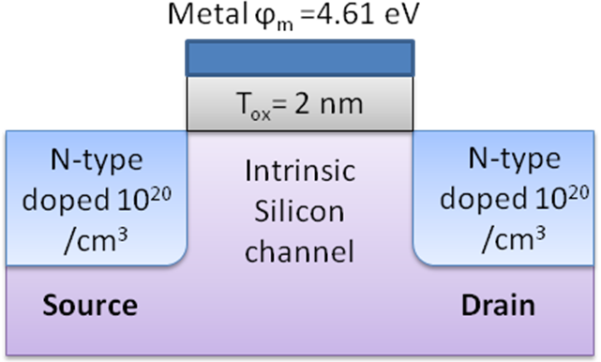
Figure 1

  - N-type MOSFET
  - P-type MOSFET
  - Can work as both N-type and P-type MOSFETs

- What is the threshold voltage for the MOSFET in Figure 1?
  - 0.56 V
  - 1.12 V
  - 0 V

- What will be the threshold voltage if Metal is replaced with N-Poly?
  - 0.56 V
  - 1.12 V
  - 0 V
- What is the best case for increasing the ON state current of device in Figure 1?
  - Make thicker oxide.
  - Replace metal with N-poly gate.
  - Replace channel material with GaAs

- What happens if we reduce channel length?
  - Subthreshold slope ↓; DIBL ↑
  - Subthreshold slope ↓; DIBL ↓
  - Subthreshold slope ↑; DIBL ↑

- What is the ideal sub threshold slope at room temperature?
  - 100 mV/dec
  - 60 mV/dec
  - 25 mV/dec

- A Silicon based NMOS has W=10µm and L=100µm and Bulk mobility, µ_{n}=600 cm²/V.s. What should be device dimension for the PMOS (µ_{p}=300 cm²/V.s) to have same ON state current.
  - W=10µm ; L=50µm
  - W=50µm ; L=200µm
  - W=10µm ; L=100µm

- Which of the following will lead to higher transconductance g_{m}?
  - Reducing oxide thickness
  - Increasing channel length
  - Reducing mobility

- By what factor should the following parameters be multiplied while reducing MOSFET channel length by a factor β and keeping the same electric field within the device?

 | Oxide thickness | Width | Drain bias
 | β | β | 1/β
 | 1 | 1/β | β
 | 1/β | 1/β | 1/β

- What is the typical thickness of inversion layer formed below oxide?
  - 0.1 nm
  - 2 nm
  - 10 nm

- Under what condition would punchthrough happen?
  - Thickness, t_{ox}→ 0
  - Length, L_{channel}→ 0
  - Doping Na → 0

- Which of the following is not a short channel effect?
  - Punchthrough
  - Reducing subthreshold slope
  - Increasing DIBL

- Which of the following MOSFET device would have least sub threshold slope?
  - Bulk MOSFET
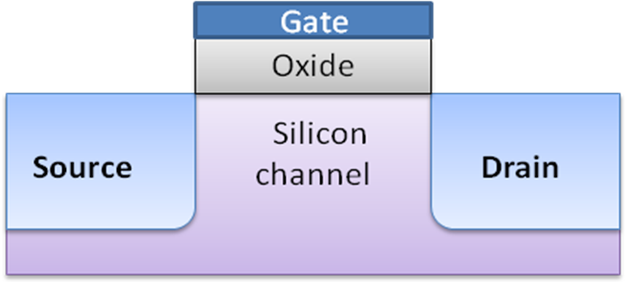
  - UTB MOSFET
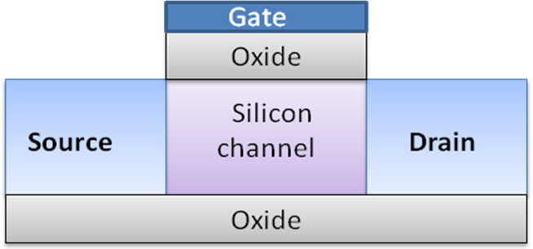
  - Double Gate MOSFET
