A Guide to the MIT Atomic Scale Modeling Toolkit for nanoHUB.org
Dr. Enrique Guerrero – University of California, Merced
- Introduction
- Getting Started
- Classical Molecular Dynamics: Lennard-Jones
- Classical Molecular Dynamics: Carbon Nanotube
- Revisiting Quantum ESPRESSO: Phonons
- Classical Monte Carlo

- Introduction
This document is a guide to using the MIT Atomic Scale Modeling Toolkit found at https://nanohub.org/resources/ucb_compnano . The guide was designed to be presented as part III of the nanoHUB seminar “A condensed matter physics class and a Course-based Undergraduate Research Experience (CURE) with the MIT Atomic-Scale Modeling Toolkit.” This module has been used to aid in teaching condensed matter physics and can be used as a pedagogical tool in a range of courses including density functional theory, materials physics, computational physics, or similar courses. The interface is intended to allow students without computational research experience to run molecular simulations. For many of the input parameters, mousing over the text reveals a description of the input’s purpose.

The current suite of available applications includes the following (underlined objects are covered in this tutorial):
- Averages and Error Bars: a tool for simple statistical analysis and comparison. One or more two-coordinate data sets can be input, then their mean, standard error of the mean, standard error of the standard error, and autocorrelation are computed.
- Molecular Dynamics (Lennard-Jones): an interface with LAMMPS ( https://lammps.org ) that uses the simplistic Lennard-Jones potential.
- Molecular Dynamics (Carbon Nanostructures and More): another LAMMPS interface better suited for Carbon systems.
- Monte Carlo (Hard Sphere): a Metropolis Monte Carlo simulation where atoms only interact when within a certain radius.
- Monte Carlo (Ising Model): an implementation of the Ising model in 3D which allows the user to control the size, interaction strength, and external field.
- Quantum Chemistry (GAMESS): an interfacefor GAMESS an ab initio molecular quantum chemistry code ( https://www.msg.chem.iastate.edu/gamess/capabilities.html )
- DFT for Solids and 2D Materials (Quantum ESPRESSO): an interface for the plane-wave DFT code Quantum ESPRESSO ( https://www.quantum-espresso.org/ ) with a more detailed guide found at https://nanohub.org/resources/ucb_compnano
- Crystalline Structures and Densities (XCrySDen): an interface for XCrySDen ( http://www.xcrysden.org/ ) to visualize input atomic coordinates and associated surfaces as still images or animations.
- DFT for Solids, Nanostructures, and Molecules (SIESTA): an interface to SIESTA ( https://departments.icmab.es/leem/siesta/ ) a DFT code that uses localized atomic orbitals as a basis set.
- Quantum Monte Carlo (Qwalk): an interface to QWALK ( https://qwalk.github.io/mainline/ ) a package that performs Monte Carlo electronic structure computations for many-electron molecules and solids.

This document uses screenshots and lists to prompt the user to make changes on nanoHUB.

Prompt $→$ Input Objects highlighted in green indicate that a new input is to be changed for the task.
Feel free to alter and/or share this guide to fit your classroom’s needs. For suggested changes to this document please email Enrique Guerrero (eguerrero23@ucmerced.edu) or David A. Strubbe (dstrubbe@ucmerced.edu). For suggested changes to the toolkit, or to report bugs, questions can be sent through nanoHUB’s interface directly: https://nanohub.org/resources/ucb_compnano/questions .

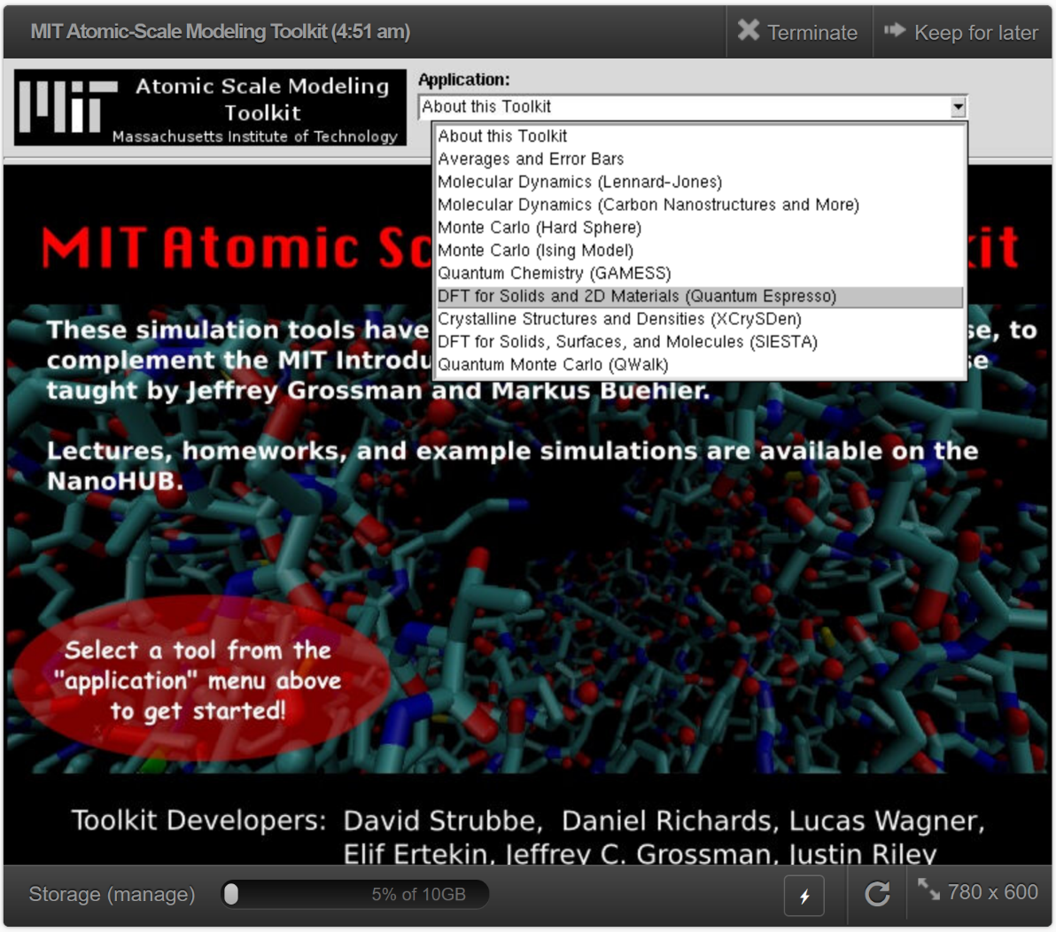
Getting Started

- Go to https://nanohub.org/tools/ucb_compnano
- Click “Launch Tool”
  - Login or Signup to a nanoHUB account if you haven’t done so
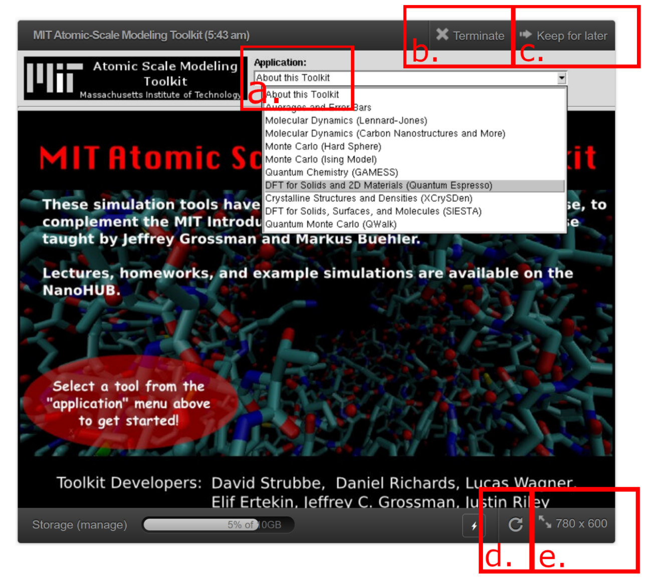
- Note important interface
  - Choose among tools installed in this toolkit, we are focusing on Quantum ESPRESSO
  - “Terminate”: Ends the current session. If you close your browser, your session will still be active (with three active sessions allotted per user)
  - “Keep for later”: Does not end the session. Restart your session by choosing “Open” in your Dashboard
  - Refresh the session is useful if the application does not respond or is frozen.
  - Resizing the window can be used to see options that are otherwise not visible.

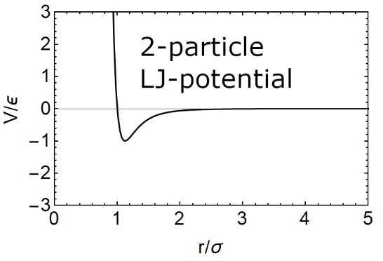
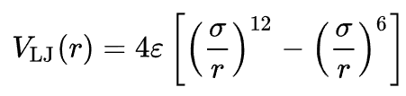
- Classical Molecular Dynamics: Lennard-Jones
- Info: The Lennard-Jones system is quite powerful given its simplicity. The classical pair potential requires empirical parameters for $σ$ (particle ‘size’) and $ϵ$ (well depth). It captures the strong Pauli repulsion at small distances, attraction at medium range, and lack of interaction at far distances. We will compute a material of particles interacting via the Lennard-Jones and vary the density. This section uses the free and open-source molecular simulation code LAMMPS ( https://lammps.org ).
- Select the Molecular Dynamics (Lennard-Jones) Application
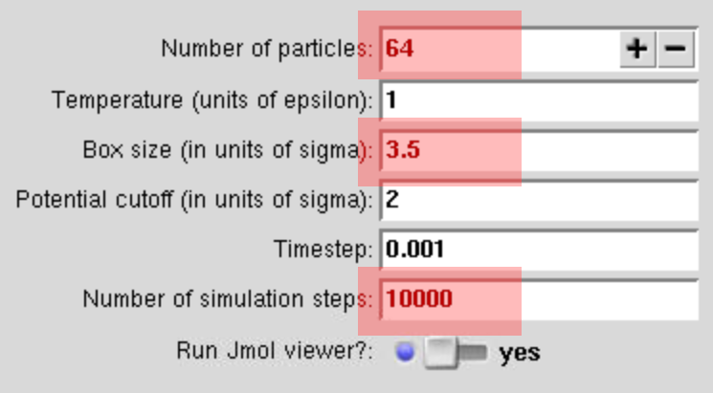
- Alter the input parameters:
  - Number of particles $→$ 64
  - Box size (in units of sigma) $→$ 3.5
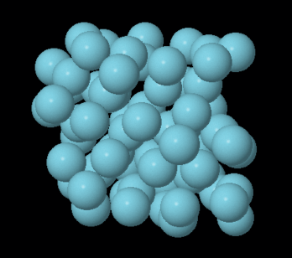
  - Number of simulation steps: 10000
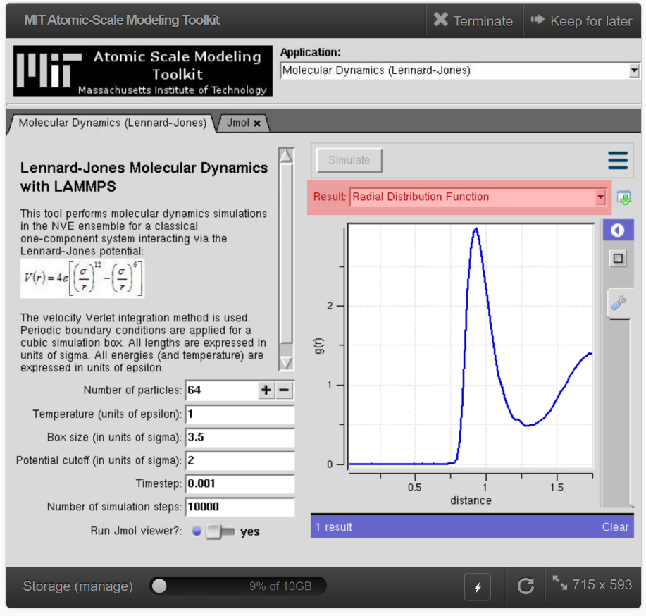
- Press Simulate. If “Run Jmol viewer?” was left on, an animation will show a dense Lennard-Jones material
- Click on the “Molecular Dynamics (Lennard-Jones)” tab to return to the input.
- Click on “LAMMPS: Log File”. The initial section of this output log shows the LAMMPS parameters used, they can be compared against the LAMMPS documentation if so desired ( https://docs.lammps.org/ ).
- Click on the “Velocity Autocorrelation Function” file in the Result options. This tells us how much the system has evolved away from the initial state. Values near zero is a good sign that the system is sufficiently equilibrated.
- Click on the “Radial Distribution Function” file in the Result options. This plot gives the relative likelihood that two particles are a given distance away. A $g(r)$ value of $0$ indicates that the likelihood is indistinguishable from a random arrangement of atoms.
- Set Box size (in units of sigma) $→$ 4.5 then press Simulate.
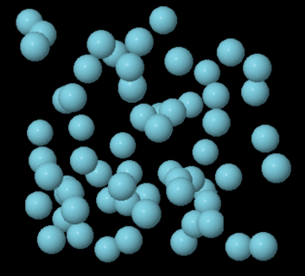
  - Repeat this for 5.5 and 6.5 to get a range of densities. Notice the more gas-like behavior of the animations at low densities.
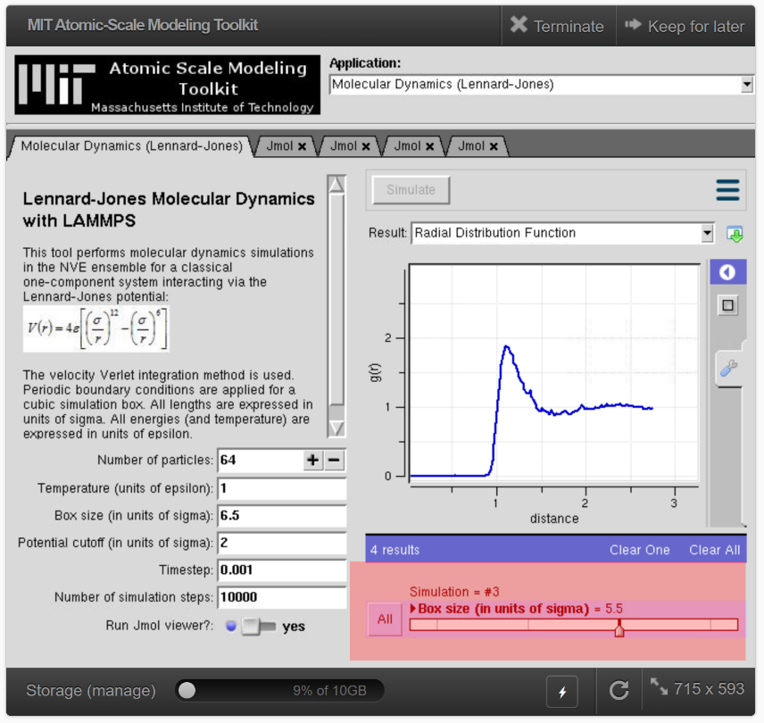
- Revisit the “Velocity Autocorrelation Function” and “Radial Distribution Function” files. Slide the slider between different runs in the bottom-right corner. Are the lowest density computations sufficiently equilibrated? What density-dependent behavior exists in $g(r)$? As a bonus, you can download the “Pressures” for two of the runs, then upload them to the Averages and Error Bars application to compare statistical averages.

- Carbon Nanostructures:
- Select the Molecular Dynamics (Carbon Nanostructures and More) Application
- Info: The Carbon Nanostructure app is a simplistic interface to the LAMMPS code that uses more sophisticated potentials than the Lennard-Jones, e.g. Tersoff potential. Several carbon nanostructures are preloaded as potential structures to study, but arbitrary input atomic coordinates are allowed. We will run a few computations of defected carbon nanotubes. This will allude to how the quantity-based CURE (Course-based Undergraduate Research Experience) approach could be used by students to study unique materials in parallel.
- Set “Compute stress?” $→$ yes
- Set “XYZ Coordinates” $→$ (6,6) CNT
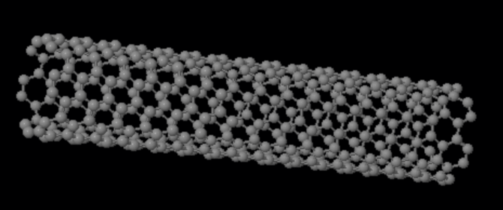
- Simulate.
- Info: We have chosen to minimize the atomic coordinates. The Carbon nanotube will be animated as the atoms relax. Outside of the list of available CNT configurations, many tools are available to generate other chirality tubes (e.g. TubeGen https://turin.nss.udel.edu/research/tubegenonline.html ).
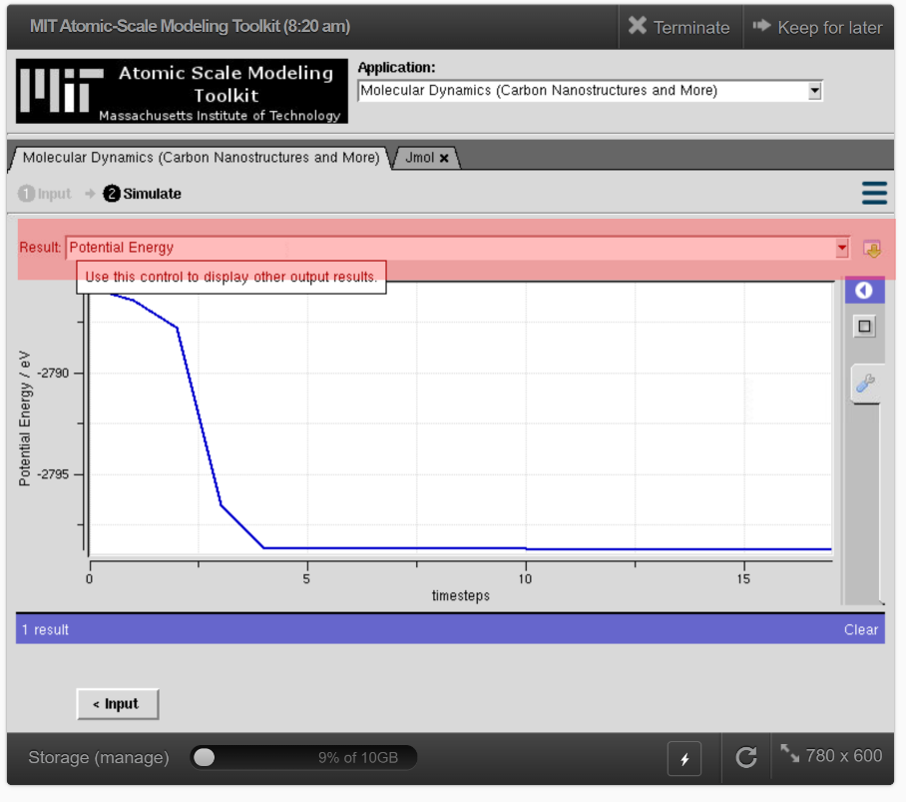
- There are several files in the Result dropdown after returning to the Molecular Dynamics tab. Most relevant is the “Potential Energy”, which allows you to view the change in energy over time.
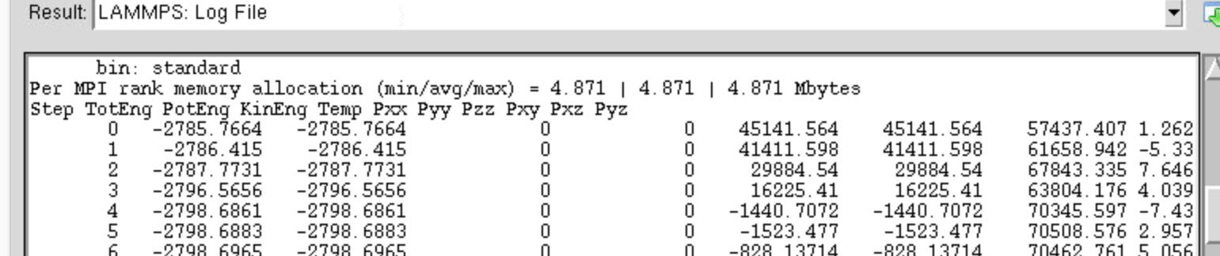
- The coordinate files could be downloaded for external data analyses. Scrolling down in the “LAMMPS: Log File” shows the pressure or stress “Pxx …” and so on. “Pzz” (same axis as CNT periodicity) could be studied against different strains to compute the elasticity of the material, i.e. Young’s Modulus (see Quantum ESPRESSO tutorial).
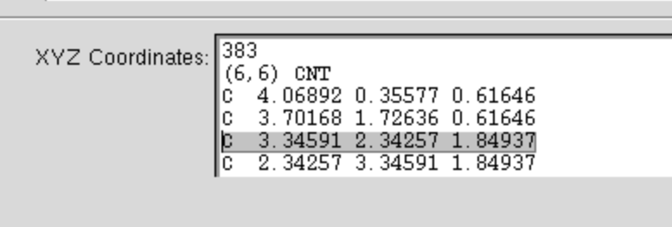
- Return to the Input.
- Introduce a defect by removing an atom from the system, changing 384 to 383, and deleting one line. Simulate.
- Return to the Input.
- Delete a second atom. Ideally, different students chose different pairs of vacancies. Simulate. If working alone, return to the Input, reset the (6,6) CNT input, and delete a different pair of atoms then Simulate again.
- Open the “Potential Energy” plot in the “Molecular Dynamics” tab. Did your double vacancies produce different energies? Are divacancies more energetically favorable than distant single vacancies? In practice, different students would create a unique material and the data could be aggregated. More complex actions (e.g. band structures with DFT) could be computed independently by students with their own material.
- Revisiting ESPRESSO: Phonons
- Select the DFT for Solids and 2D Materials (Quantum ESPRESSO) application
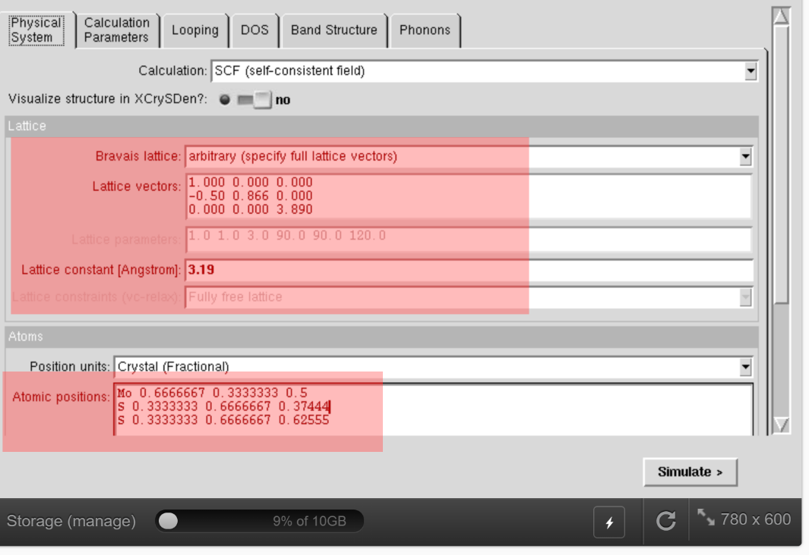
- Info: We have gone into detail using the ESPRESSO module in the previous session, so we recommend downloading the ESPRESSO guide from the following link
( https://nanohub.org/resources/ucb_compnano ) if this app is of interest. The paradigm in this module it that there are two main tabs: the “Physical System” tab to describe your system and the “Calculation Parameters” tab to choose the levels of DFT approximations. We are going to compute the Raman spectra of monolayer MoS₂. We will run a fast version of the computation, but the approximations will be quite harsh.
- In the “Physical System” tab:
  - Set Bravais lattice $→$“arbitrary (specify full lattice vectors)”
  - Set Lattice vectors $→$
1.000 0.000 0.000
-0.50 0.866 0.000
0.000 0.000 3.890
  - Set Lattice constant [Angstrom] $→$ 3.19
  - Set Atomic positions $→$
Mo 0.666667 0.33333 0.5
S 0.33333 0.666667 0.37444
S 0.33333 0.666667 0.62555
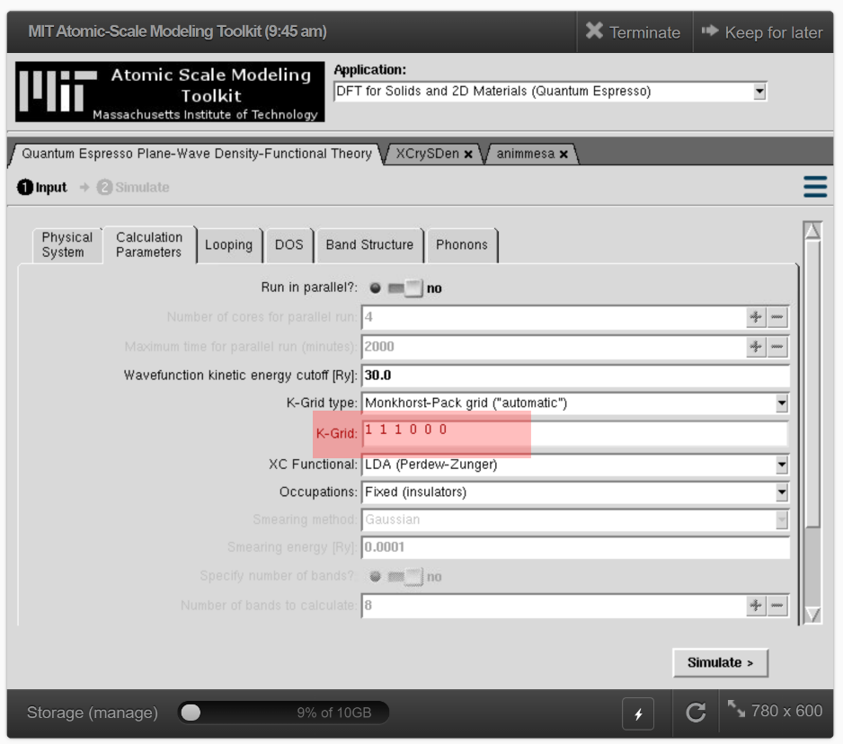
- In the “Calculation Parameters” tab:
  - Set K-Grid $→$ 1 1 1 0 0 0
  - Info: These parameters give us a monolayer MoS₂ whose unit cell has only three atoms. The default 30 Ry Wavefunction cutoff and K-Grid 1 1 1 0 0 0 (i.e. gamma point only) are weak approximations, but they will save a lot of computation time for the purposes of this tutorial. MoS₂ has a band gap, so we treat it as an “insulator” for the “Occupations” option, despite being a well-known semiconductor.
- In the “Phonons” tab:
  - Set Calculate only q=0? $→$ yes
  - Set Calculate Raman intensities? $→$ yes
  - Set Visualize q=0 mode in XCrySDen? $→$ yes
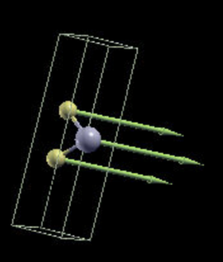
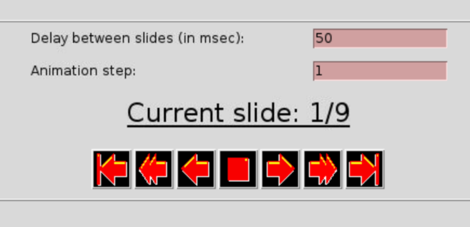
- Simulate.
  - The resulting tabs that appeared are XCrySDen’s visualization and a slider for the different phonon modes. There should be $3×number of atoms$ modes, one for each degree of freedom. Click on the XCrySDen tab to see the visualization. Press “f” or navigate the menu to “Display $→$ Forces” within XCrySDen. This shows arrows that represent the phonon modes.
  - Click the “Quantum Espresso Plane-Wave Density-Functional Theory” tab.
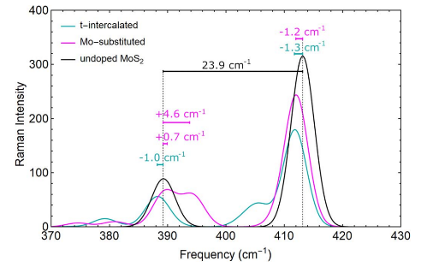
  - Click the Raman Spectrum plot to view the spectra. Use left clicks to encircle the important active region, how well does it match the reference: (O. Acikgoz et al. Nanotechnol. 34, 015706, expt left, computation right, black lines are for MoS₂)?
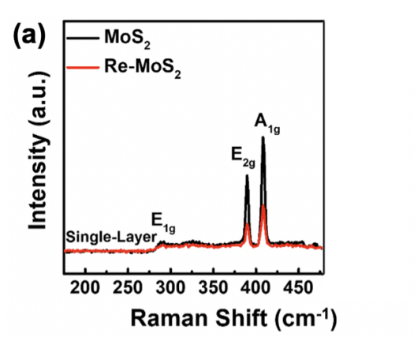

- Classical Monte Carlo
- Select the Monte Carlo (Ising Model) Application
- Info: The Ising Model is a simplistic model of ferromagnetism often used to introduce Monte Carlo simulation in statistical mechanics. The energetics of the system involve competing components between a polarizable region of matter and an external field, a region and a neighboring region, and heat-mediated entropy. The “regions of matter” are represented as sites with variable polarization. The model has two main tabs: the “Ising Simulations” tab shows a real-time animation representing a cross-section of the system while the “Set Model Parameters” tab (when Change Parameters is selected) allows us to manipulate the model’s control knobs.
- Select “Change Parameters”:
  - Set Number of x lattice points $→$ 10
  - Set Number of y lattice points $→$ 10
  - Set Number of z lattice points $→$ 2
  - Set Number of y lattice points $→$ 10
  - Select “Set These Parameters” and return to the “Ising Simulations” tab.
  - Select “Start” to begin the simulation.
  - Info: By default, the polarization was constrained to the z-axis only. We are seeing a view along the z-axis of an xy-slice of the material, with blue being polarized in +z and orange being -z. The temperature and external field were set to 0, while J was set to +1.0. In this configuration, the system prioritizes large domains because neighboring. What is expected if we set J to -1.0? What physical systems do these relate to?
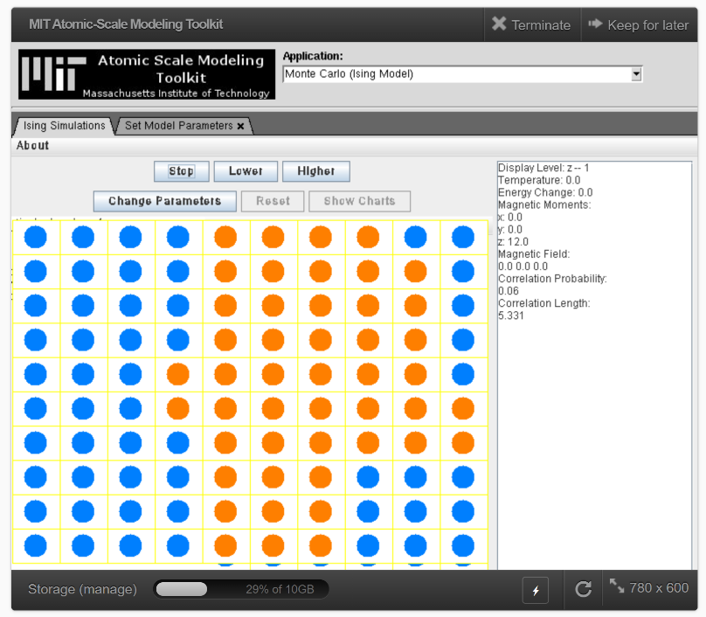
  - Select “Stop” to pause the simulation.
  - In the “Set Model Parameters” tab, Change the constraint from “Constrained to Z Axis” to “Constrained to XY Plane”
  - Set Temperature $→$ 10.0
  - Set Temperature Decline Percentage $→$ 1.0
  - Set Interaction Strength $→$ 1.0
  - Set the Magnetic Field Strength, Y $→$ 10.0
  - Chose “Set These Parameters” and return to the “Ising Simulations” tab.
  - Select “Reset” and then “Start”
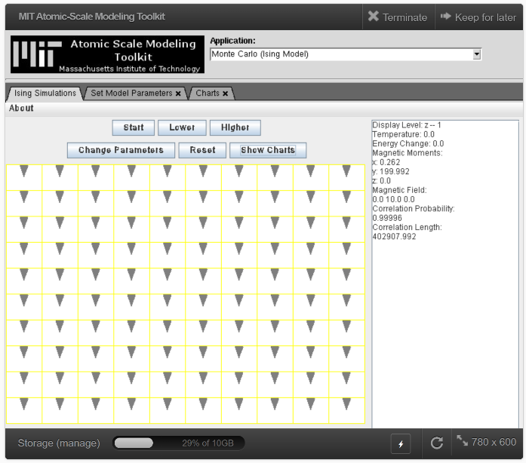
  - Info: We have set an external field in the y-direction and began the simulation at high temperature. The slow reduction of temperature or “simulated annealing” eases the system in to a stable equilibrium where neighboring sites are aligned with the field and each other.

