A Guide to the MIT Atomic Scale Modeling Toolkit for nanoHUB.org
Dr. Enrique Guerrero – University of California, Merced
- Introduction
- Getting Started
- Explore input and output interfaces
- Example: Silicon Wavefunction Kinetic Energy Cutoff
- Example: Silicon Bulk Modulus
- Example: Silicon Density of States and Band Structure
- Example: Silicon Phonon Frequencies and Raman Intensities

- Introduction
This document is a guide to the Quantum ESPRESSO application within the MIT Atomic Scale Modeling Toolkit found at https://nanohub.org/resources/ucb_compnano . The guide was designed to be presented as part II of the nanoHUB seminar “A condensed matter physics class and a Course-based Undergraduate Research Experience (CURE) with the MIT Atomic-Scale Modeling Toolkit”. This module has been used to aid in teaching condensed matter physics and can be used as a pedagogical tool in a range of courses including density functional theory, materials physics, computational physics, or similar courses. The interface is built perhaps as a “black box” with a few windows. Simple inputs are transferred to Quantum ESPRESSO v6.1 and then outputs are parsed and displayed. Depending on the teacher’s plan, different inputs and outputs could be the focus of instruction.

This document begins with a few tasks to familiarize the user with the toolkit. Four examples involving Silicon will show off a few of the application’s capabilities while getting the user used to the interface and get a sense for its intentional limits and intended use.

The guide uses snapshots with red squares indicating that letter is the focus of this micro-task or explanation.

Prompt $→$ Input Objects highlighted in green indicate that a new input is to be changed for the task.

Feel free to alter and/or share this guide to fit your classroom’s needs. For suggested changes to this document please email Enrique Guerrero (eguerrero23@ucmerced.edu) or David A. Strubbe (dstrubbe@ucmerced.edu). For suggested changes to the toolkit, or to report bugs, questions can be sent through nanoHUB’s interface directly: https://nanohub.org/resources/ucb_compnano/questions .

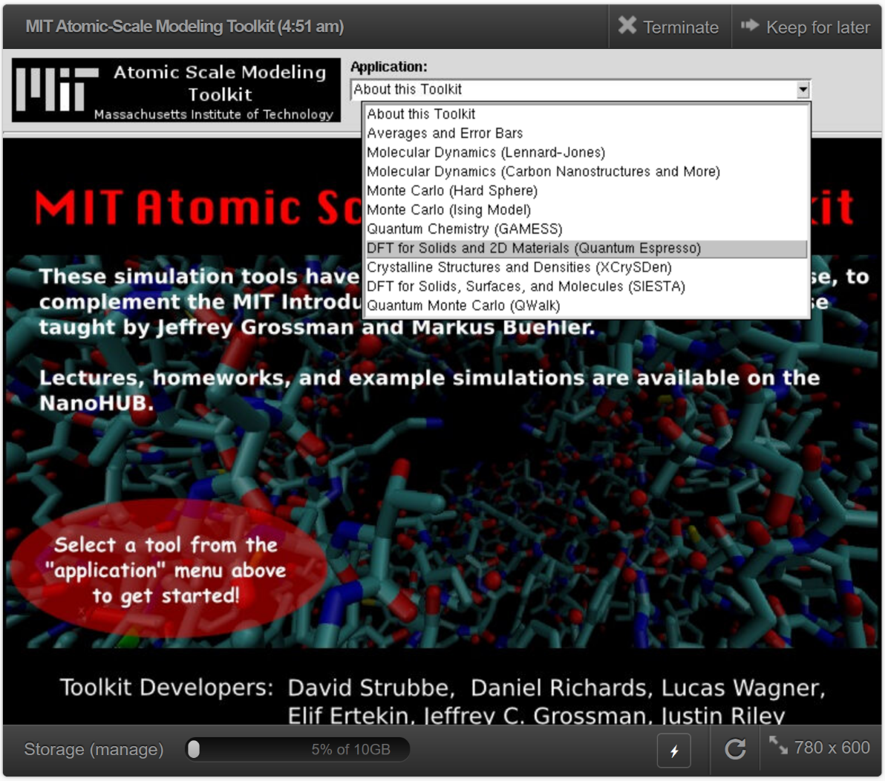
- Getting Started

- Go to https://nanohub.org/tools/ucb_compnano
- Click “Launch Tool”
  - Login or Signup to a nanoHUB account if you haven’t done so
- Under Application, select “DFT for Solids and 2D Materials (Quantum Espresso)”

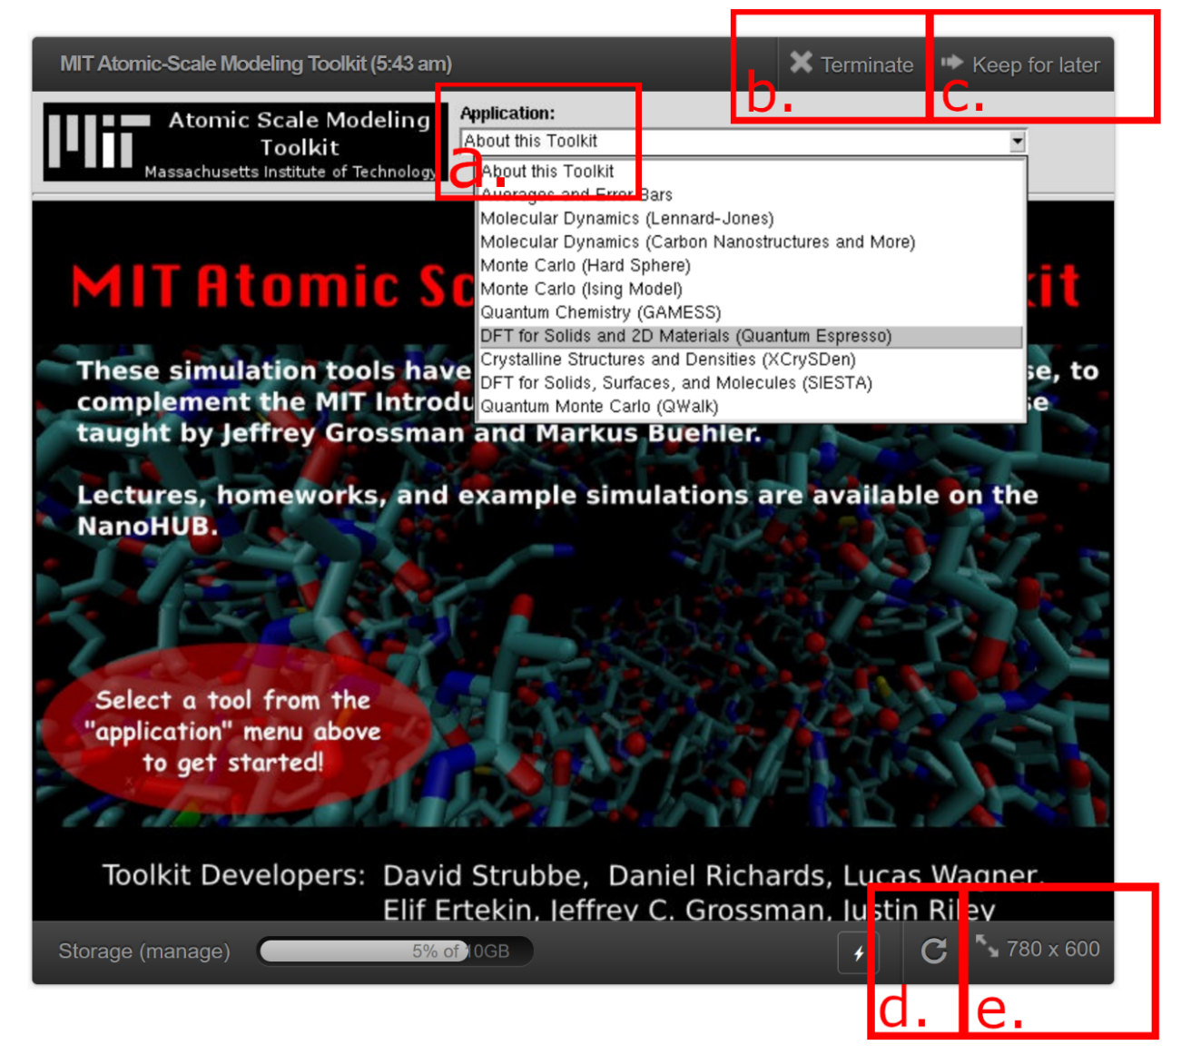
- Note important interface
  - Choose among tools installed in this toolkit, we are focusing on Quantum ESPRESSO
  - “Terminate”: Ends the current session. If you close your browser, your session will still be active (with three active sessions allotted per user)
  - “Keep for later”: Does not end the session. Restart your session by choosing “Open” in your Dashboard
  - Refresh the session is useful if the application does not respond or is frozen.
  - Resizing the window can be used to see options that are otherwise not visible.

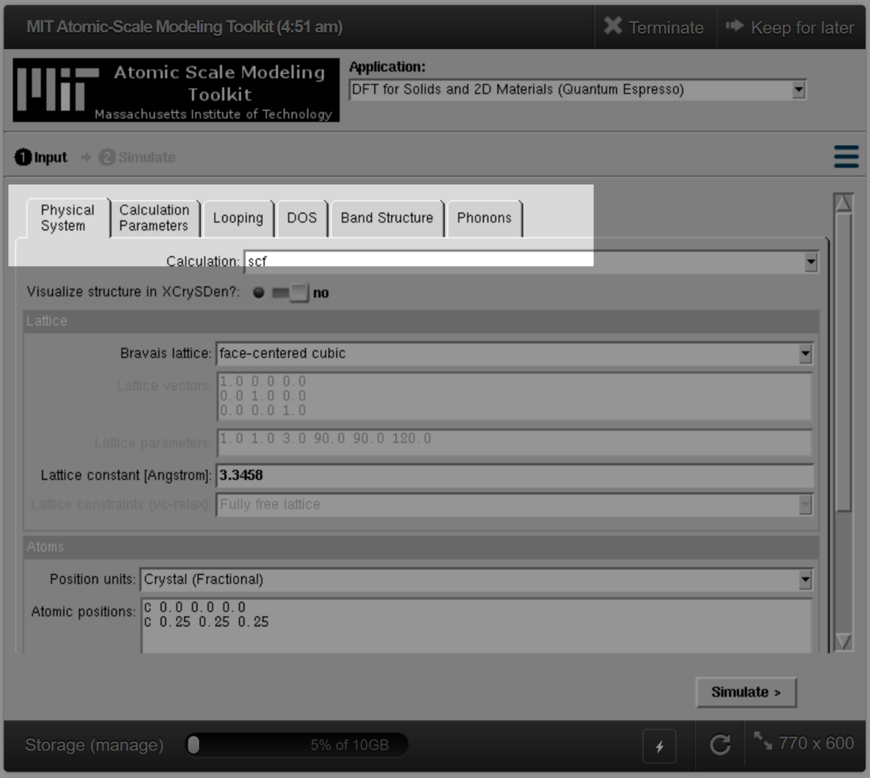
- Explore input and output interfaces:
- Visit the tabs and overview their options. The first two tabs set up the system, while the last four are optional tasks to send to ESPRESSO:
  - “Physical System”: Change computation type, choose to visualize system, set lattice parameters, set or upload atomic positions
  - “Calculation Parameters”: Set parallel computing, change kinetic energy cutoff and k-grid, change functionals, alter electron and band treatment
  - “Looping”: Set multiple computations to run with an altered parameter (implemented: lattice size, kinetic energy cutoff, SCF-threshold)
  - “DOS”: Compute density of states
  - “Band Structure”: Set or upload pathway through Brillouin zone to compute band structure
  - “Phonons”: Compute phonon frequencies, visualize phonon eigenmodes; compute phonon density of states, phonon band structures, or Raman intensities.

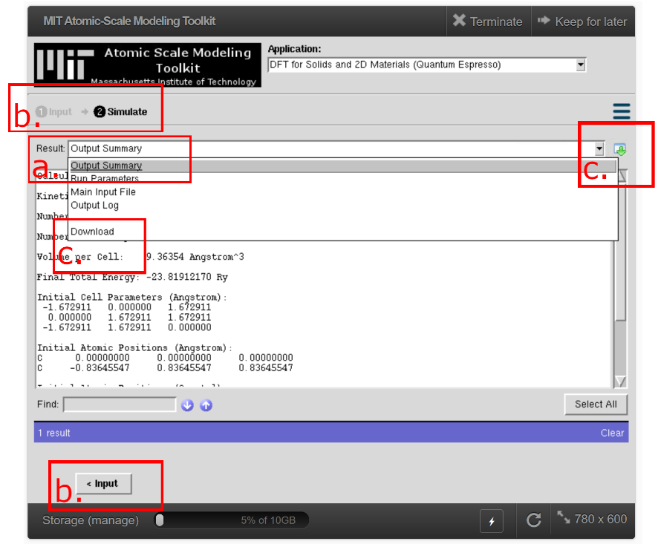
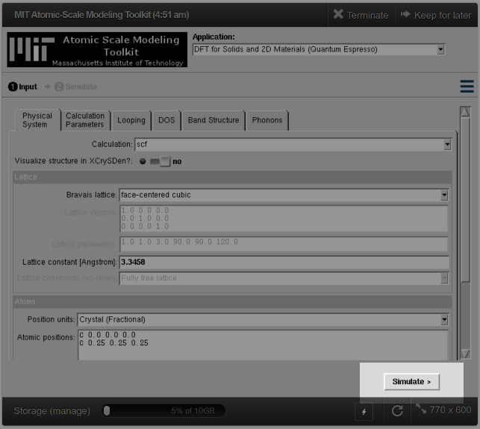
- Click on “Simulate” using all default parameters to get a sense for the output
  - The dropdown allows you to change the output file to view (depending on the calculation, we may have a different list of available files)
  - You can cycle between the input and the simulation
  - Files are available to download for external processing

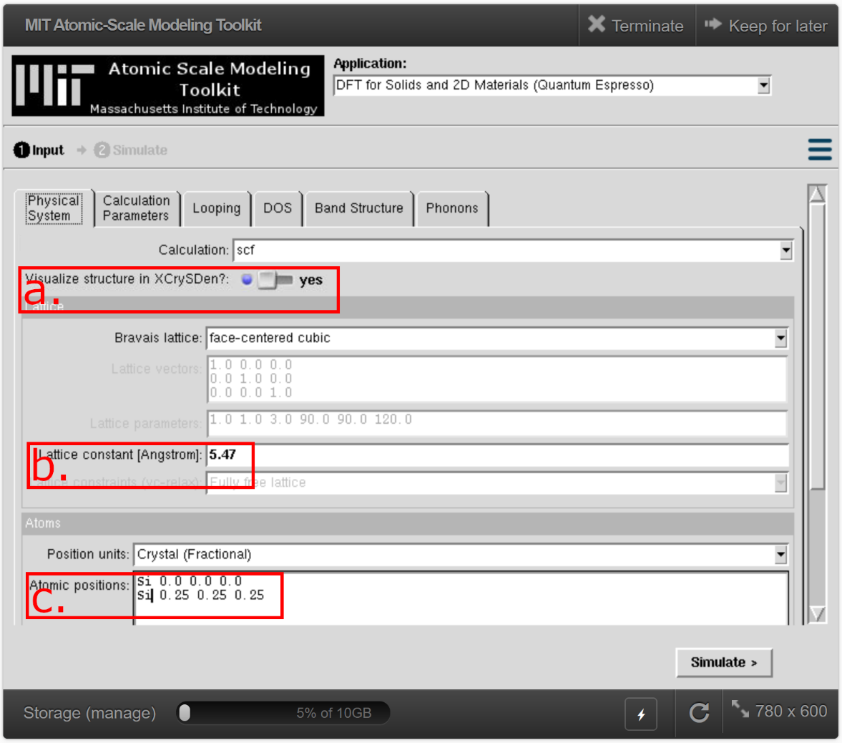
- Example: Silicon Wavefunction Kinetic Energy Cutoff
- Physical System tab:
  - Visualize structure in XCrySDen? $→$yes
    - Helps us see the structure to verify it is the structure we intend
  - Lattice constant [Angstrom] $→$ 5.47
    - As a first guess, we can check the material at the Materials Project https://materialsproject.org/materials
      - Login or Sign up for free to the Materials Project, this project attempts to gather computations of
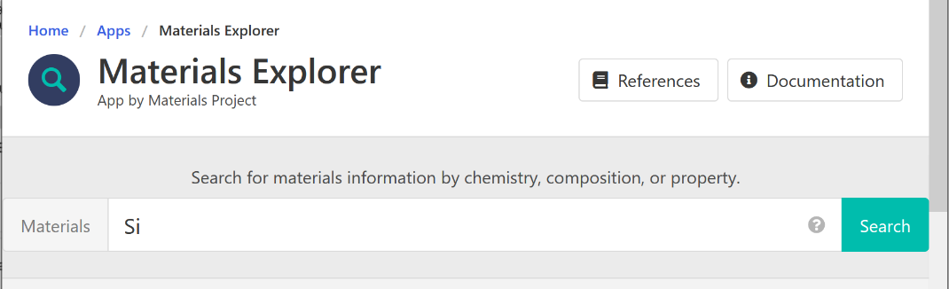
      - Search for “Si” only on the Materials Explorer search bar.
      - Select the low formation energy (starred) mp-149 with the correct Fd3̅m1 symmetry
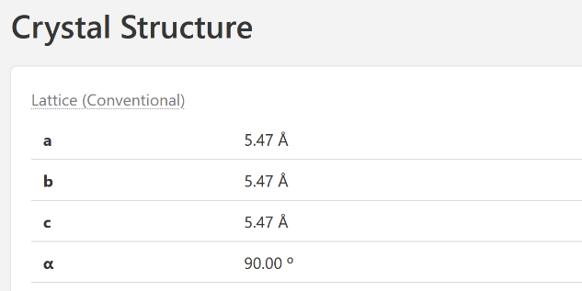
      - Navigate to the lattice information and write it into the Physical System tab
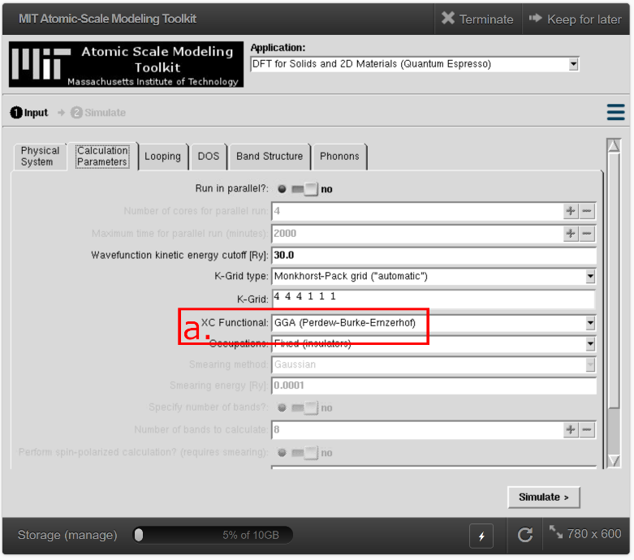
  - Atomic Positions $→$
Si 0.0 0.0 0.0
Si 0.25 0.25 0.25 (NOTE: We are using Si not C)

- Calculation Parameters:
  - XC Functional $→$ GGA (Perdew-Burke-Ernzerhof)
    - Kinetic energy cutoffs will be taken care of in the “Looping” tab. The value in this tab is used in the main calculation.
    - We use GGA as we know the bond lengths to be more accurate than LDA
    - “Occupations” stay as “Fixed” because diamond Si is an insulator

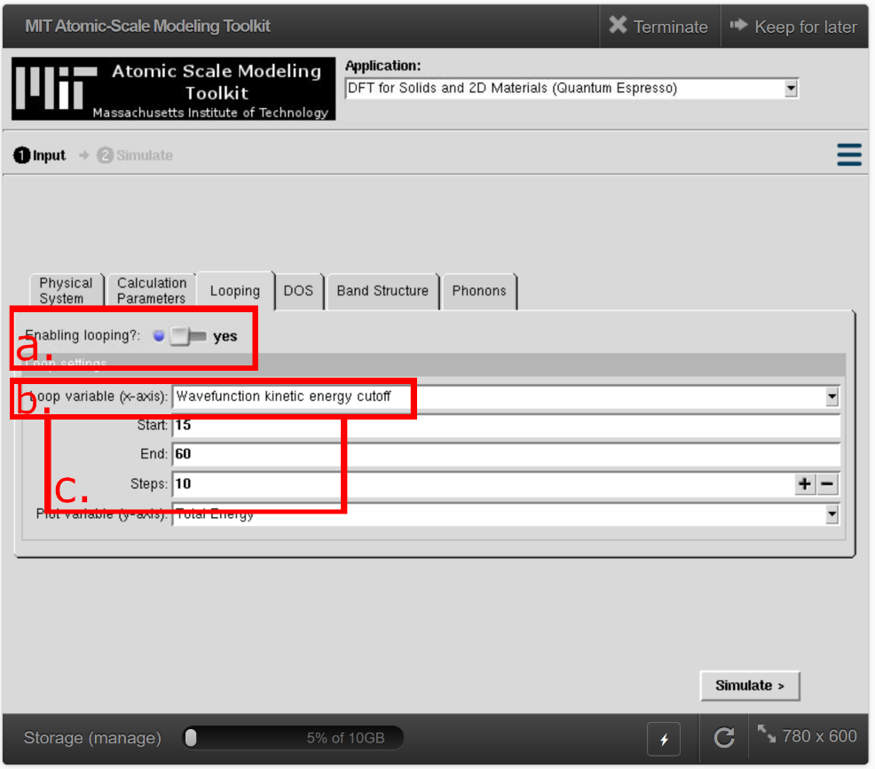
- Looping:
  - Enable looping? $→$yes
    - Allows us to run several computations with different kinetic energy cutoffs
  - Loop variable (x-axis) $→$Wavefunction kinetic energy cutoff
    - will change the number of plane waves in the basis functions used to describe the electronic states. A larger cutoff leads to higher accuracy, but also more computation time.
  - Start $→$15; End $→$60; End $→$10
    - We will loop from 15 Ry to 60 Ry in 10 steps (with a 5 Ry interval). These values are relatively low, but the certain Pseudopotential we use is designed to be accurate at low kinetic energy cutoffs.
- Make sure DOS, Band Structure, and Phonon options are turned OFF then hit “Simulate”.
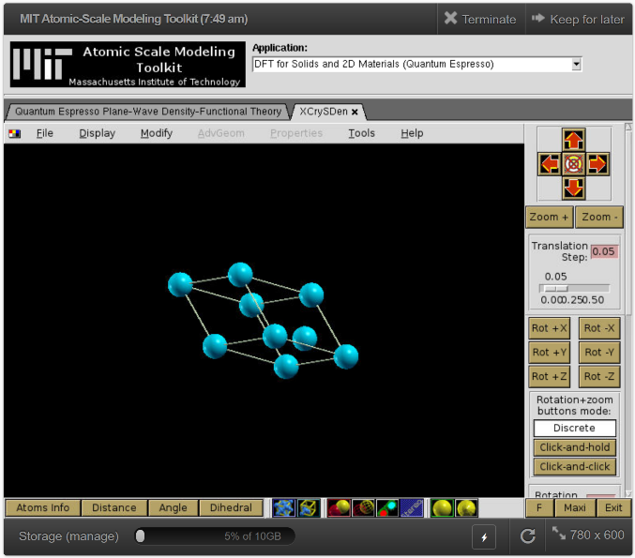
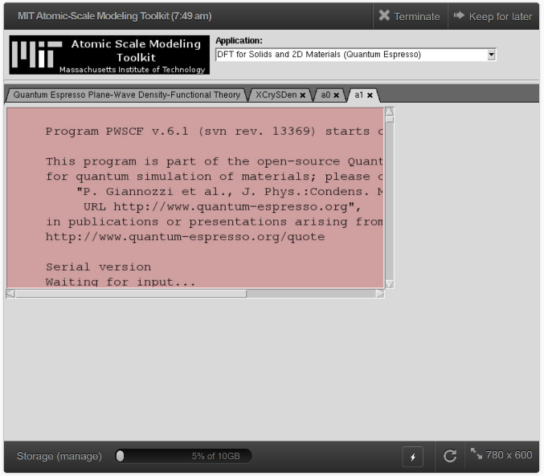
- Results:
  - XCrySDen displays two windows, the “a1” window has info logs that are not usually important to us, so we can close that tab. In “a0,” select “do not reduce dimensionality” and select “OK”. An option to display different coordinates will be shown, for SCF only one option is available.
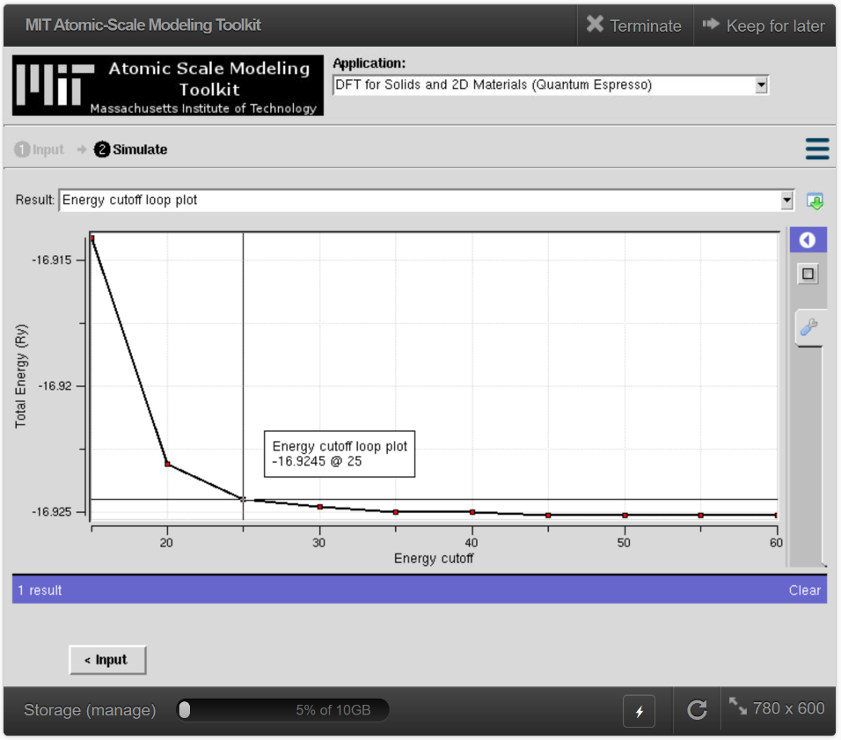
  - You can drag the system around; the lines represent the repeating crystal lattice. It can be repeated in the options under “Modify”.

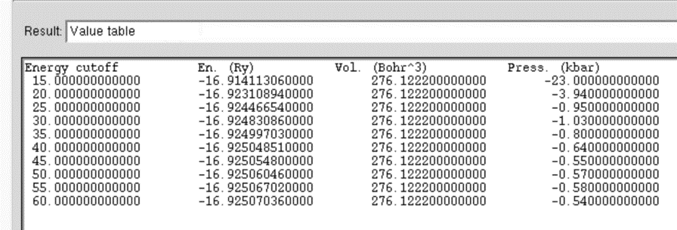
  - When the Loop tab is used, a plot will appear that compares the chosen variable against the loop variable.
  - The “Value table” strips a few parameters from the output files, this file can be useful to download for external processing.
  - Other Notes:
    - The “Output Summary” gives more details about the main computation (with energy cutoff in the “Computation” tab)
    - The “Run Parameters” file gives many internal variables used that may be useful when looking for differences between two files.
    - The “Main Input File” is the raw input file that is used in Quantum ESPRESSO. To understand what these inputs mean, these can be compared with the documentation at https://www.quantum-espresso.org/Doc/INPUT_PW.html
    - Similarly, the “Output Log” is the raw output log of the ESPRESSO runs and the wrapper codes’ runs. Typically, it is not useful to read this unless you are familiar with ESPRESSO output. Any errors at the end of the file after “stderr” are a sign that something bad has happened, either by bad inputs (such as setting the energy cutoff too low) or by some bug in the wrapper code that can be asked as a question through nanoHUB: https://nanohub.org/resources/ucb_compnano/questions
    - This same study is often conducted with k-points by using progressively finer k-grids. This is not implemented automatically in the Looping tab, but it can be done by students with successive computations of changing k-grid values.

- Example: Silicon Bulk Modulus
- Reset the previous Looping parameters:
  - In Physical System tab: Visualize structure in XCrySDen? $→$ no
  - In Looping tab: Enable Looping? $→$ no
- Find the ideal lattice parameter for this new combination of kinetic energy cutoff, k-grid, and pseudopotential
  - Based on previous results, in Calculation Parameters tab: Wavefunction kinetic energy cutoff [Ry] $→$25
  - In Physical System tab: Calculation $→$ vc-relax
  - Simulate.
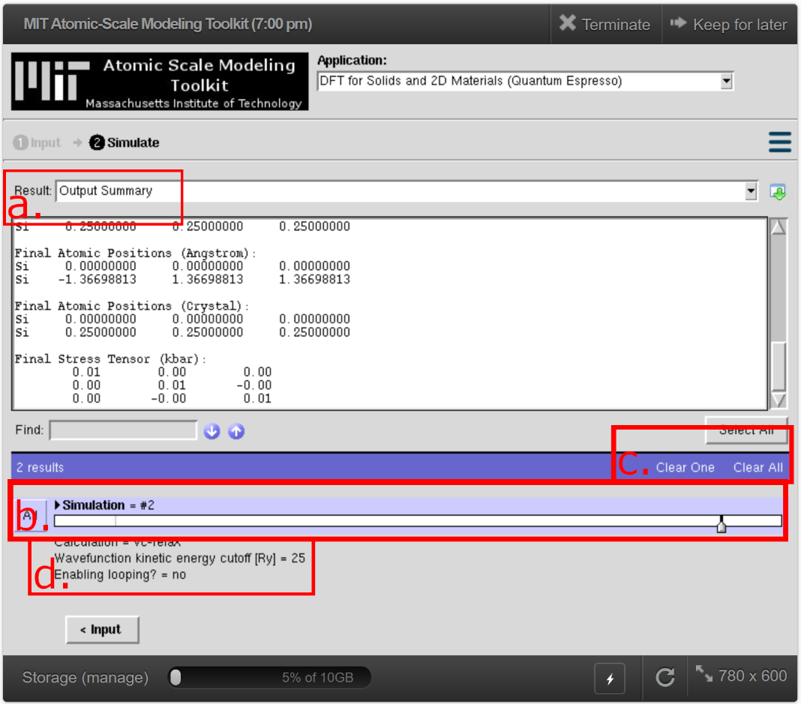
- Results (vc-relax):
  - Files like the energy plot do not exist for the new run, so it will be blank. The “Output Summary” file is worth comparing between the new and old computation. Important values to note are the kinetic energy cutoff and the Stress Tensor.
  - Previous simulations can be accessed by selecting the lines in this bar.
  - Some or all the simulations can be removed from the memory.
  - Inputs that are different between runs are displayed below the simulation bar.
  - Note the final
- Reset the previous parameters for Looping over the lattice parameter to set up the Bulk Modulus computation:
  - Return to the Input screen. In the Physical System tab, set Calculation $→$ relax. This mode allows the atoms to relax their position but keeps the lattice vectors fixed. This simulates the realistic atomic response of atoms during strain.
  - Use the result from the previous vc-relax run. In FCC, the lattice constant is 2x any of the constants in the Final Cell Parameters in the “Output Summary” file. In the Physical System tab: Lattice constant [Angstrom] $→$ 5.46795
  - In the Looping tab:
    - Enable looping? $→$ yes
    - Loop variable (x-axis) $→$ Lattice cell factor
    - Start $→$ 0.995
    - End $→$ 1.005
    - Step $→$ 10
    - Plot variable (y-axis) $→$ Pressure
- Simulate.
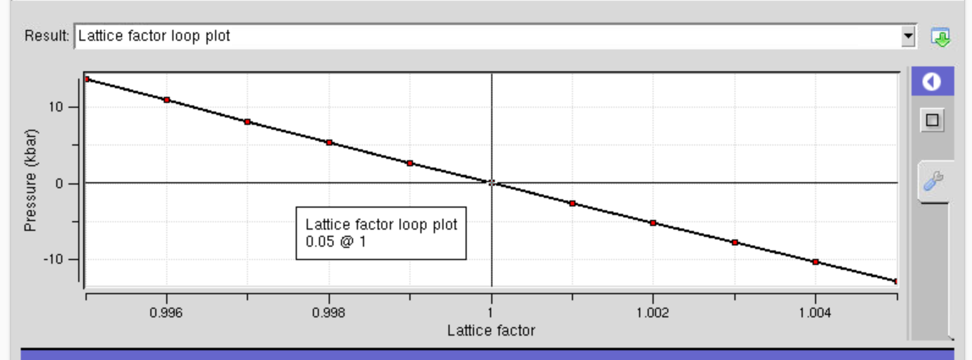
- Results
  - The “Lattice factor loop plot” shows stress vs. strain (or 1+strain vs mean of the xx, yy, and zz components of stress).
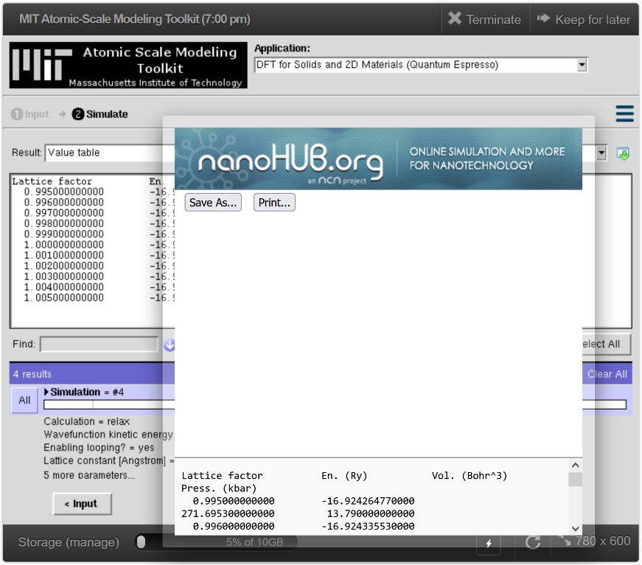
  - Download the “Value table” file and fit strain (1-lattice factor) vs stress using your code of choice. This can be done easily using Excel, for example. The slope should be the Bulk modulus.

- Example: Silicon Density of States and Band Structure
- Reset the previous parameters.
  - Physical System tab: Calculation $→$ scf
  - Looping tab: Enable looping? $→$ no
- DOS tab:
    - Compute Density of States? $→$ yes
    - Number of bands to calculate $→$ 12
    - The default values for energy resolution and K-grid are sufficient.
- Band Structure tab:
    - Compute Band Structure? $→$ yes
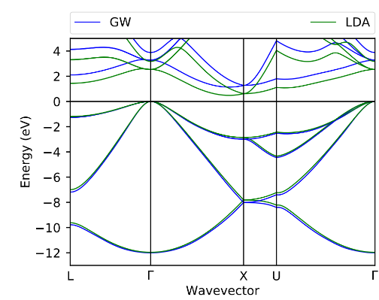
    - Leave Number of bands to calculate $→$ 8
    - Change k-point path in Brillouin zone to follow the path in this reference (from a BerkeleyGW tutorial https://physics.ucmerced.edu/sites/physics.ucmerced.edu/files/page/documents/1-silicon.pdf)
      - One of two input methods can be used. The keywords X, U, gG, etc. are available because we are using an FCC lattice. Equivalent inputs in units between keywords and using units of $2π/a$. The initial number is the number of reference points we will use. The first letter or three numbers indicate a point in the Brillouin zone, the second number indicates how many intermediate points to plot.
keywords method:
5
L 40
gG 40
X 10
U 40
gG 1
$2π/a$ method:
5
0.5 0.5 0.5 40
0.0 0.0 0.0 40
0.0 1.0 0.0 10
0.25 1.0 0.25 40
0.0 0.0 0.0 1
- Simulate.
- Results:
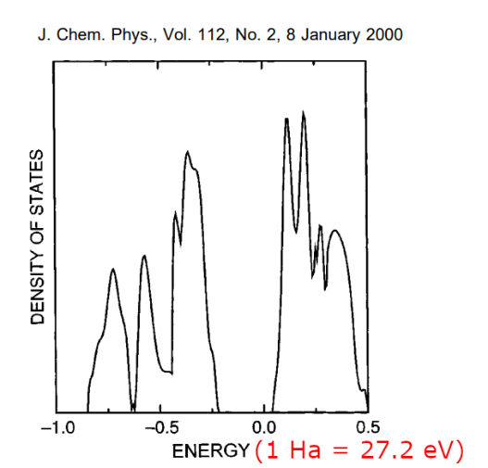
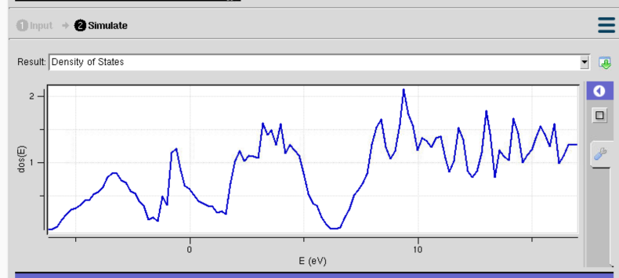
  - Density of States:
    - The DOS is plotted (Note E=0 is not actually meaningful and is not the Fermi level). General features are comparable vs. a Hartree-Fock method.
    - The “Number of bands to calculate” option in the “DOS” tabs decides how far right the band structure is computed
    - Raw “DOS Data” can be downloaded to be externally plotted
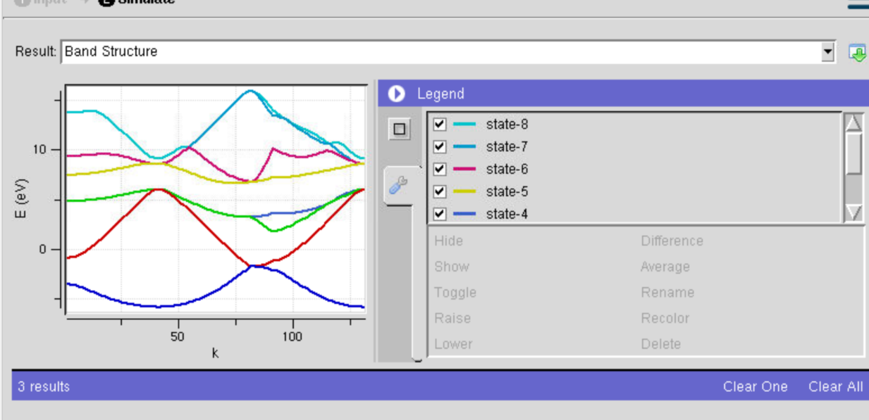
  - Band Structure:
    - The file “Band Structure” contains a plot which may be resized for easier viewing by dragging the Legend box leftward.
    - We had set the number of states to “8,” this number is highly dependent on the system. In general, count the number of valence electrons in the system and divide it by 2 to get the number of occupied states. Increase this number to view the excited states. Si has 4 valence electrons, and there are two atoms, so states 1-4 are valence bands, while states 5-8 are conduction bands.
    - “Bands Data” has the full, raw band structure data and may be parsed for external plotting.

- Example: Silicon Phonon Frequencies and Raman Intensities
- Notes:
  - ESPRESSO does not combine GGA functionals with Raman intensities. (This forum post explains why: https://lists.quantum-espresso.org/pipermail/users/2018-October/041426.html ). Thus, we have to switch to LDA. For accurate results, we should redo the vc-relaxation to find the ideal parameter. For purposes of this guide, we will skip that step and use the GGA ideal geometry.
  - For reference, Si has a Raman peak at 520 cm⁻¹.
- Reset the previous DOS and Bands plots:
  - In the Looping tab: Enable looping? $→$ no
  - In the DOS tab: Compute Density of States? $→$ no
  - In the Band Structure tab: Compute Band Structure $→$ no
  - In the Physical System tab: Calculation $→$ scf
- Calculation Parameters tab:
  - Calculation $→$ scf
  - XC Functional $→$ LDA (Perdew-Zunger)
- Phonon tab:
  - Compute phonons? $→$ yes
  - Calculate only q=0? $→$ yes
  - Calculate Raman intensities? $→$ yes
  - Visualize q=0 mode in XCrySDen? $→$ yes
- Simulate.
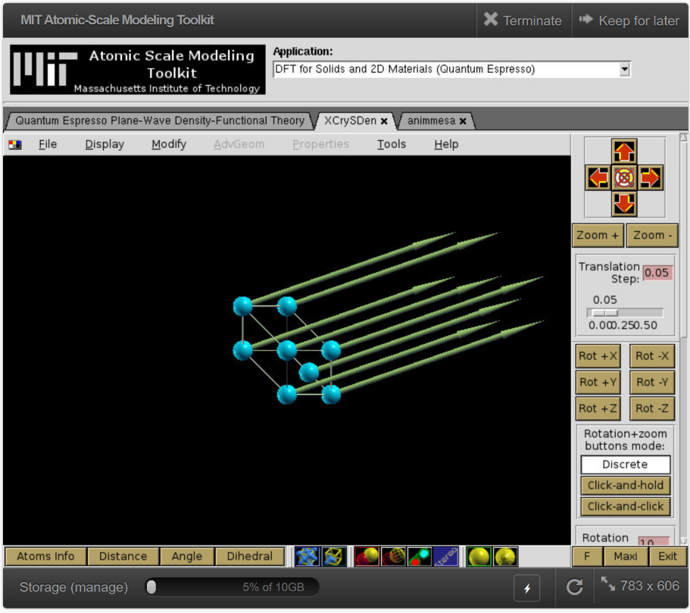
  - 3 windows will appear, with the Animation pane for XCrySDen focused. Do not remove this window, we will need it in a moment.
  - We can explore the phonon eigenmodes using XCrySDen.
    - In the options, set “Forces” on, or just click on the structure and press “f”
    - These arrows are not actually forces, but that is how XCrySDen interfaces with them. They are the eigenmode displacement directions.
    - In the animation window, moving one step forward is moving to the next highest eigenfrequency mode. Notice how the first three acoustic modes have all displacements in the same direction.
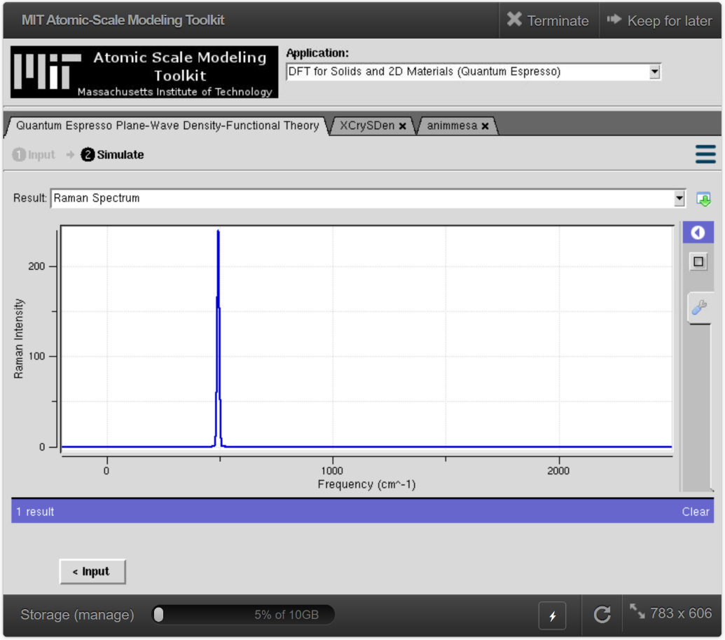
  - Go to the main output tab and select the “Raman Spectrum” file
    - The spectrum’s peak has been drawn at around 495 cm⁻¹.
    - The accuracy could be improved by increasing the K-grid density, increasing the kinetic energy cutoff, improving the geometry, or reducing the “Threshold for phonon SCF” in the Phonons tab, but each of these costs computational time.
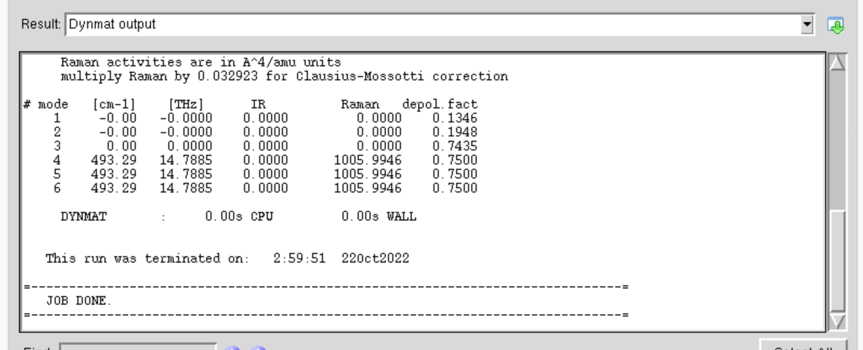
    - Raw Raman and IR intensities vs frequencies are found in the file “IR/Raman spectra raw data”
  - Go to the “Dynmat output” file and scroll down
    - This file shows all the modes, their frequencies, and their IR and Raman intensities.
    - The frequencies and intensities are the only output of ESPRESSO used to generate the previous plot—the width of the peak is artificial
    - Note there are 6 modes, one for each degree of freedom (2 atoms $×$ 3 Cartesian directions). The first three 0 cm⁻¹ frequency modes are the acoustic modes. The last three are identical due to the high symmetry in crystalline Si.

